BAB V
PENUTUP

  - Kesimpulan
Berdasarkan hasil analisis dan perhitungan maka dapat di tarik kesimpulan sebagai berikut:
- Berdasarkan tanggapan yang diberikan responden terhadap butir pernyataan yang diberikan pada kuisioner memperoleh nilai rata-rata skor sebesar 3,74. Oleh karena itu, dapat diperoleh kesimpulan bahwa tingkat kepuasan penumpang atau pengguna jasa terhadap kualitas pelayanan bus langsung indah jurusan Mataram-Bima dianggap puas berdasarkan (enam) dimensi pelayanan.
- Berdasarkan hasil evaluasi pelayanan transportasi bus langsung indah jurusan Mataram-Bima terhadap Standar Pelayanan Angkutan Penumpang Umum pada Kawasan Strategis Nasional Menurut Peraturan Menteri Perhubungan Nomor 52 Tahun 2019 disimpulkan bahwa pelayanan bus langsung indah sudah cukup memenuhi kriteria Peraturan Menteri Perhubungan Nomor 52 Tahun 2019. Nilai persentase bus langsung indah 84% fasilitas yang telah ada dan 16% yang fasilitas yang belum tersedia.

  - Saran
Berdasarkan kesimpulan terdapat saran guna memperbaiki hal tersebut, seperti penyebaran kuisioner dapat dilakukan pada terminal keberangkatan dan pada lokasi penjemputan untuk mengetahui pengguna pelayanan jasa pada transportasi secara menyeluruh.

DAFTAR PUSTAKA
Damayanti, R., Usman, B., & Putra, A. E. (2017). Analisis Kualitas Pelayanan Angkutan Umum (Transmusi) Melalui Kinerja Terhadap Kepuasan Masyarakat di Kota Palembang. 15(1).
Dian, B., & Sandy, A. (2019). Analisis Kepuasan Penumpang Terhadap Pelayanan Bus Sekolah Kota Surabaya Dengan Metode Important Performance Analysis. 5(2), 100–111.
Fassa, F., Jhon, F., Sitorus, P., & Adikesuma, T. N. (2017). Kinerja Pelayanan Shuttle Bus Di Kota Mandiri. Seminar NASIONAL Sains Dan Teknologi 2017, November, 1–2.
Hasyim, M., & Listiawan, T. (2014). Penerapan Aplikasi IBM SPSS Untuk Analisis Data Bagi Pengajar Pondok Hidayatul Mubtadi’in Ngunut Tulungagung Demi Meningkatkan Kualitas Pembelajaran dan Kreativitas Karya Ilmiah Guru. Jurnal Pengabdian Kepada Masyarakat, 2(1), 28–35.
Idris, Z. (2009). Kajian “TINGKAT KEPUASAN” Pengguna Angkutan Umum di DIY. Dinamika Teknik Sipil, 9(2), 189–196. https://doi.org/10.2169/naika.56.1379
Junior, N. P. S., Rumayar, A. L. E., & Sendow, T. K. (2016). Analisis Kebutuhan Angkutan Umum Penumpang Kota Manado. Jurnal Sipil Statik, 4(6), 367–373.
Leliana, A., & Oktaviastuti, B. (2020). Analisis Kepuasan Penumpang Kereta Api Terhadap Angkutan Umum di Stasiun Madiun. 5(1), 1–6.
Mahendra, I. (2017). Analisis Kualitas Pelayanan Pada Angkutan Umum Angkutan Koperasi Daerah Kabupaten Purworejo. Fakultas Ekonomi Universitas Islam Indonesia, Universitas Islam Indonesia, kualitas pelayanan pada angkutan umum di yogyakarta, 1–15.
Moha, S., & Loindong, S. (2016). Analisis Kualitas Pelayanan Dan Fasilitas Terhadap Kepuasan Konsumen Pada Hotel Yuta Di Kota Manado. Jurnal EMBA, 4(1), 575–584.
Mustafa, A., & Sugiarto. (2013). Analisis Pengaruh Kualitas Pelayanan Terhadap Kepuasan Penghuni ( Studi Kasus Rusunawa Jurug Surakarta ). Matriks Teknik Sipil, 1(2), 63.
Ong, J. O., & Pambudi, J. (2014). Importance Performance Analysis Di SBU Laboratory Cibitung PT SUCOFINDO (PERSERO). Jurnal Teknik Industri UNDIP, IX(1), 8–9.
Prima, G. R. (2020). Tingkat Kepuasan Pengguna Jasa Terhadap Pelayanan Angkutan Umum Perkotaan di Kota Tasikmalaya. 6(2), 129–140.
Sumanga, U. A. (2013). Analisis Kepuasan Pengguna Jasa Terhadap Penerapan. Media Engineering, 3(1), 6–13.
Wedagama, D. M. ., Suthanaya, P. A., & Pramana, P. C. A. (2020). Analisis Kinerja Layanan Angkutan Umum Massal Bus Trans Sarbagita Berdasarkan Persepsi Kepuasan Penumpang. Jurnal Spektran, 8(1), 11–18.
Sugiyono, 2014. Metode Penelitian Pendidikan Pendekatan Kuantitatif, Kualitatif, dan R&D. Bandung: Alfabeta.

LAMPIRAN

LAMPIRAN I
JAWABAN PENUMPANG BERDASARKAN KINERJA/KEPUASAN DAN KEPENTINGAN

Lampiran 1
JAWABAN PENUMPANG BERDASARKAN KINERJA/KEPUASAN

JAWABAN PENUMPANG BERDASARKAN KINERJA/KEPENTINGAN

LAMPIRAN II
PERHITUNGAN NILAI RATA-RATA PENILAIAN KINERJA TERHADAP KEPUASAN

Lampiran 2 Perhitungan nilai rata-rata Penilaian Kinerja Terhadap Kepuasan

LAMPIRAN III
HASIL UJI VALIDITAS MENGGUNAKAN SPSS

Lampiran 3 Hasil Uji Validitas menggunakan SPSS
Correlations
 |  | P1 | P2 | P3 | P4 | P5 | P6 | P7 | P8 | P9 | P10 | P11 | P12 | P13
P1 | Pearson Correlation | 1 | .158 | .233* | .202* | .122 | .163 | .077 | .078 | -.168 | .038 | .093 | -.023 | .048
 | Sig. (2-tailed) |  | .116 | .019 | .044 | .225 | .105 | .445 | .440 | .095 | .706 | .356 | .821 | .638
 | N | 100 | 100 | 100 | 100 | 100 | 100 | 100 | 100 | 100 | 100 | 100 | 100 | 100
P2 | Pearson Correlation | .158 | 1 | .127 | .063 | .089 | .160 | .147 | .136 | .096 | .118 | .111 | .018 | .151
 | Sig. (2-tailed) | .116 |  | .207 | .534 | .381 | .112 | .145 | .177 | .340 | .243 | .270 | .858 | .133
 | N | 100 | 100 | 100 | 100 | 100 | 100 | 100 | 100 | 100 | 100 | 100 | 100 | 100
P3 | Pearson Correlation | .233* | .127 | 1 | -.030 | .111 | .283** | .214* | .096 | -.007 | .286** | -.120 | .047 | .209*
 | Sig. (2-tailed) | .019 | .207 |  | .764 | .272 | .004 | .032 | .340 | .941 | .004 | .236 | .641 | .037
 | N | 100 | 100 | 100 | 100 | 100 | 100 | 100 | 100 | 100 | 100 | 100 | 100 | 100
P4 | Pearson Correlation | .202* | .063 | -.030 | 1 | .090 | .017 | .095 | .168 | -.075 | -.092 | .142 | .069 | .114
 | Sig. (2-tailed) | .044 | .534 | .764 |  | .375 | .864 | .346 | .094 | .457 | .365 | .159 | .496 | .258
 | N | 100 | 100 | 100 | 100 | 100 | 100 | 100 | 100 | 100 | 100 | 100 | 100 | 100
P5 | Pearson Correlation | .122 | .089 | .111 | .090 | 1 | .208* | .002 | .221* | -.061 | .067 | .260** | .135 | .149
 | Sig. (2-tailed) | .225 | .381 | .272 | .375 |  | .038 | .987 | .027 | .544 | .505 | .009 | .181 | .138
 | N | 100 | 100 | 100 | 100 | 100 | 100 | 100 | 100 | 100 | 100 | 100 | 100 | 100
P6 | Pearson Correlation | .163 | .160 | .283** | .017 | .208* | 1 | .160 | .086 | -.154 | .181 | .152 | -.066 | .065
 | Sig. (2-tailed) | .105 | .112 | .004 | .864 | .038 |  | .112 | .394 | .125 | .072 | .132 | .513 | .523
 | N | 100 | 100 | 100 | 100 | 100 | 100 | 100 | 100 | 100 | 100 | 100 | 100 | 100
P7 | Pearson Correlation | .077 | .147 | .214* | .095 | .002 | .160 | 1 | .137 | .067 | .129 | .009 | .054 | .140
 | Sig. (2-tailed) | .445 | .145 | .032 | .346 | .987 | .112 |  | .173 | .509 | .199 | .930 | .596 | .166
 | N | 100 | 100 | 100 | 100 | 100 | 100 | 100 | 100 | 100 | 100 | 100 | 100 | 100
P8 | Pearson Correlation | .078 | .136 | .096 | .168 | .221* | .086 | .137 | 1 | -.054 | -.071 | .145 | .056 | .188
 | Sig. (2-tailed) | .440 | .177 | .340 | .094 | .027 | .394 | .173 |  | .591 | .482 | .149 | .580 | .062
 | N | 100 | 100 | 100 | 100 | 100 | 100 | 100 | 100 | 100 | 100 | 100 | 100 | 100
P9 | Pearson Correlation | -.168 | .096 | -.007 | -.075 | -.061 | -.154 | .067 | -.054 | 1 | .271** | .021 | .170 | .045
 | Sig. (2-tailed) | .095 | .340 | .941 | .457 | .544 | .125 | .509 | .591 |  | .006 | .833 | .091 | .660
 | N | 100 | 100 | 100 | 100 | 100 | 100 | 100 | 100 | 100 | 100 | 100 | 100 | 100
P10 | Pearson Correlation | .038 | .118 | .286** | -.092 | .067 | .181 | .129 | -.071 | .271** | 1 | .041 | .190 | .117
 | Sig. (2-tailed) | .706 | .243 | .004 | .365 | .505 | .072 | .199 | .482 | .006 |  | .685 | .059 | .246
 | N | 100 | 100 | 100 | 100 | 100 | 100 | 100 | 100 | 100 | 100 | 100 | 100 | 100
P11 | Pearson Correlation | .093 | .111 | -.120 | .142 | .260** | .152 | .009 | .145 | .021 | .041 | 1 | .194 | .284**
 | Sig. (2-tailed) | .356 | .270 | .236 | .159 | .009 | .132 | .930 | .149 | .833 | .685 |  | .053 | .004
 | N | 100 | 100 | 100 | 100 | 100 | 100 | 100 | 100 | 100 | 100 | 100 | 100 | 100
P12 | Pearson Correlation | -.023 | .018 | .047 | .069 | .135 | -.066 | .054 | .056 | .170 | .190 | .194 | 1 | .233*
 | Sig. (2-tailed) | .821 | .858 | .641 | .496 | .181 | .513 | .596 | .580 | .091 | .059 | .053 |  | .020
 | N | 100 | 100 | 100 | 100 | 100 | 100 | 100 | 100 | 100 | 100 | 100 | 100 | 100
P13 | Pearson Correlation | .048 | .151 | .209* | .114 | .149 | .065 | .140 | .188 | .045 | .117 | .284** | .233* | 1
 | Sig. (2-tailed) | .638 | .133 | .037 | .258 | .138 | .523 | .166 | .062 | .660 | .246 | .004 | .020
 | N | 100 | 100 | 100 | 100 | 100 | 100 | 100 | 100 | 100 | 100 | 100 | 100 | 100
P14 | Pearson Correlation | .035 | .133 | .037 | .185 | .066 | .036 | .205* | .158 | .217* | .138 | .151 | .220* | .155
 | Sig. (2-tailed) | .733 | .187 | .717 | .065 | .511 | .719 | .040 | .115 | .030 | .170 | .133 | .028 | .124
 | N | 100 | 100 | 100 | 100 | 100 | 100 | 100 | 100 | 100 | 100 | 100 | 100 | 100
P15 | Pearson Correlation | .130 | .060 | .133 | .139 | .083 | .343** | .117 | .235* | .094 | .081 | .035 | -.064 | -.114
 | Sig. (2-tailed) | .197 | .556 | .188 | .169 | .413 | .000 | .245 | .018 | .351 | .422 | .730 | .526 | .258
 | N | 100 | 100 | 100 | 100 | 100 | 100 | 100 | 100 | 100 | 100 | 100 | 100 | 100
P16 | Pearson Correlation | .000 | .176 | -.104 | .000 | .066 | .010 | .074 | -.014 | .139 | .070 | .064 | -.085 | -.045
 | Sig. (2-tailed) | 1.000 | .080 | .303 | 1.000 | .515 | .919 | .464 | .893 | .168 | .489 | .529 | .401 | .659
 | N | 100 | 100 | 100 | 100 | 100 | 100 | 100 | 100 | 100 | 100 | 100 | 100 | 100
TOTAL | Pearson Correlation | .383** | .441** | .440** | .335** | .433** | .459** | .417** | .397** | .220* | .416** | .404** | .334** | .447**
 | Sig. (2-tailed) | .000 | .000 | .000 | .001 | .000 | .000 | .000 | .000 | .028 | .000 | .000 | .001 | .000
 | N | 100 | 100 | 100 | 100 | 100 | 100 | 100 | 100 | 100 | 100 | 100 | 100 | 100

Correlations
 |  | P14 | P15 | P16 | TOTAL
P1 | Pearson Correlation | .035 | .130 | .000 | .383**
 | Sig. (2-tailed) | .733 | .197 | 1.000 | .000
 | N | 100 | 100 | 100 | 100
P2 | Pearson Correlation | .133 | .060 | .176 | .441**
 | Sig. (2-tailed) | .187 | .556 | .080 | .000
 | N | 100 | 100 | 100 | 100
P3 | Pearson Correlation | .037 | .133 | -.104 | .440**
 | Sig. (2-tailed) | .717 | .188 | .303 | .000
 | N | 100 | 100 | 100 | 100
P4 | Pearson Correlation | .185 | .139 | .000 | .335**
 | Sig. (2-tailed) | .065 | .169 | 1.000 | .001
 | N | 100 | 100 | 100 | 100
P5 | Pearson Correlation | .066 | .083 | .066 | .433**
 | Sig. (2-tailed) | .511 | .413 | .515 | .000
 | N | 100 | 100 | 100 | 100
P6 | Pearson Correlation | .036 | .343** | .010 | .459**
 | Sig. (2-tailed) | .719 | .000 | .919 | .000
 | N | 100 | 100 | 100 | 100
P7 | Pearson Correlation | .205* | .117 | .074 | .417**
 | Sig. (2-tailed) | .040 | .245 | .464 | .000
 | N | 100 | 100 | 100 | 100
P8 | Pearson Correlation | .158 | .235* | -.014 | .397**
 | Sig. (2-tailed) | .115 | .018 | .893 | .000
 | N | 100 | 100 | 100 | 100
P9 | Pearson Correlation | .217* | .094 | .139 | .220*
 | Sig. (2-tailed) | .030 | .351 | .168 | .028
 | N | 100 | 100 | 100 | 100
P10 | Pearson Correlation | .138 | .081 | .070 | .416**
 | Sig. (2-tailed) | .170 | .422 | .489 | .000
 | N | 100 | 100 | 100 | 100
P11 | Pearson Correlation | .151 | .035 | .064 | .404**
 | Sig. (2-tailed) | .133 | .730 | .529 | .000
 | N | 100 | 100 | 100 | 100
P12 | Pearson Correlation | .220* | -.064 | -.085 | .334**
 | Sig. (2-tailed) | .028 | .526 | .401 | .001
 | N | 100 | 100 | 100 | 100
P13 | Pearson Correlation | .155 | -.114 | -.045 | .447**
 | Sig. (2-tailed) | .124 | .258 | .659 | .000
 | N | 100 | 100 | 100 | 100
P14 | Pearson Correlation | 1 | .143 | .053 | .445**
 | Sig. (2-tailed) |  | .155 | .600 | .000
 | N | 100 | 100 | 100 | 100
P15 | Pearson Correlation | .143 | 1 | .095 | .404**
 | Sig. (2-tailed) | .155 |  | .348 | .000
 | N | 100 | 100 | 100 | 100
P16 | Pearson Correlation | .053 | .095 | 1 | .218*
 | Sig. (2-tailed) | .600 | .348 |  | .029
 | N | 100 | 100 | 100 | 100
TOTAL | Pearson Correlation | .445** | .404** | .218* | 1
 | Sig. (2-tailed) | .000 | .000 | .029
 | N | 100 | 100 | 100 | 100

*. Correlation is significant at the 0.05 level (2-tailed).
**. Correlation is significant at the 0.01 level (2-tailed).

RELIABILITY
/VARIABLES=P1 P2 P3 P4 P5 P6 P7 P8 P9 P10 P11 P12 P13 P14 P15 P16
/SCALE('ALL VARIABLES') ALL
/MODEL=ALPHA
/SUMMARY=TOTAl

LAMPIRAN IV
HASIL UJI RELIABILITAS MENGGUNAKAN SPSS

Lampiran 4 Hasil Uji Reliabilitas Menggunakan SPSS
Case Processing Summary
 |  | N | %
Cases | Valid | 100 | 100.0
 | Excludedª | 0 | .0
 | Total | 100 | 100.0

a. Listwise deletion based on all variables in the procedure.

Reliability Statistics
Cronbach's Alpha | N of Items
.626 | 16

Item-Total Statistics
 | Scale Mean if Item Deleted | Scale Variance if Item Deleted | Corrected Item-Total Correlation | Cronbach's Alpha if Item Deleted
P1 | 56.18 | 32.998 | .214 | .616
P2 | 56.62 | 32.581 | .297 | .603
P3 | 56.51 | 32.192 | .276 | .606
P4 | 56.04 | 33.837 | .180 | .620
P5 | 56.41 | 32.467 | .278 | .605
P6 | 56.83 | 31.900 | .296 | .602
P7 | 56.31 | 33.024 | .279 | .606
P8 | 56.23 | 33.532 | .271 | .608
P9 | 56.03 | 35.363 | .085 | .631
P10 | 55.68 | 32.866 | .269 | .607
P11 | 55.92 | 33.266 | .269 | .607
P12 | 55.73 | 33.936 | .185 | .619
P13 | 56.12 | 32.349 | .295 | .603
P14 | 55.64 | 32.940 | .320 | .601
P15 | 56.21 | 33.056 | .258 | .609
P16 | 55.89 | 35.331 | .076 | .633

CORRELATIONS
/VARIABLES=P1 P2 P3 P4 P5 P6 P7 P8 P9 P10 P11 P12 P13 P14 P15 P16 TOTAL
/PRINT=TWOTAIL NOSIG
/MISSING=PAIRWISE.

Correlations
Notes
Output Created |  | 05-AUG-2021 06:43:55
Comments
Input | Active Dataset | DataSet0
 | Filter | <none>
 | Weight | <none>
 | Split File | <none>
 | N of Rows in Working Data File | 100
Missing Value Handling | Definition of Missing | User-defined missing values are treated as missing.
 | Cases Used | Statistics for each pair of variables are based on all the cases with valid data for that pair.
Syntax |  | CORRELATIONS  /VARIABLES=P1 P2 P3 P4 P5 P6 P7 P8 P9 P10 P11 P12 P13 P14 P15 P16 TOTAL  /PRINT=TWOTAIL NOSIG  /MISSING=PAIRWISE.
Resources | Processor Time | 00:00:00.02
 | Elapsed Time | 00:00:00.03

Correlations
 |  | P1 | P2 | P3 | P4 | P5 | P6 | P7 | P8 | P9 | P10 | P11 | P12 | P13
P1 | Pearson Correlation | 1 | .158 | .233* | .202* | .122 | .163 | .077 | .078 | -.168 | .038 | .093 | -.023 | .048
 | Sig. (2-tailed) |  | .116 | .019 | .044 | .225 | .105 | .445 | .440 | .095 | .706 | .356 | .821 | .638
 | N | 100 | 100 | 100 | 100 | 100 | 100 | 100 | 100 | 100 | 100 | 100 | 100 | 100
P2 | Pearson Correlation | .158 | 1 | .127 | .063 | .089 | .160 | .147 | .136 | .096 | .118 | .111 | .018 | .151
 | Sig. (2-tailed) | .116 |  | .207 | .534 | .381 | .112 | .145 | .177 | .340 | .243 | .270 | .858 | .133
 | N | 100 | 100 | 100 | 100 | 100 | 100 | 100 | 100 | 100 | 100 | 100 | 100 | 100
P3 | Pearson Correlation | .233* | .127 | 1 | -.030 | .111 | .283** | .214* | .096 | -.007 | .286** | -.120 | .047 | .209*
 | Sig. (2-tailed) | .019 | .207 |  | .764 | .272 | .004 | .032 | .340 | .941 | .004 | .236 | .641 | .037
 | N | 100 | 100 | 100 | 100 | 100 | 100 | 100 | 100 | 100 | 100 | 100 | 100 | 100
P4 | Pearson Correlation | .202* | .063 | -.030 | 1 | .090 | .017 | .095 | .168 | -.075 | -.092 | .142 | .069 | .114
 | Sig. (2-tailed) | .044 | .534 | .764 |  | .375 | .864 | .346 | .094 | .457 | .365 | .159 | .496 | .258
 | N | 100 | 100 | 100 | 100 | 100 | 100 | 100 | 100 | 100 | 100 | 100 | 100 | 100
P5 | Pearson Correlation | .122 | .089 | .111 | .090 | 1 | .208* | .002 | .221* | -.061 | .067 | .260** | .135 | .149
 | Sig. (2-tailed) | .225 | .381 | .272 | .375 |  | .038 | .987 | .027 | .544 | .505 | .009 | .181 | .138
 | N | 100 | 100 | 100 | 100 | 100 | 100 | 100 | 100 | 100 | 100 | 100 | 100 | 100
P6 | Pearson Correlation | .163 | .160 | .283** | .017 | .208* | 1 | .160 | .086 | -.154 | .181 | .152 | -.066 | .065
 | Sig. (2-tailed) | .105 | .112 | .004 | .864 | .038 |  | .112 | .394 | .125 | .072 | .132 | .513 | .523
 | N | 100 | 100 | 100 | 100 | 100 | 100 | 100 | 100 | 100 | 100 | 100 | 100 | 100
P7 | Pearson Correlation | .077 | .147 | .214* | .095 | .002 | .160 | 1 | .137 | .067 | .129 | .009 | .054 | .140
 | Sig. (2-tailed) | .445 | .145 | .032 | .346 | .987 | .112 |  | .173 | .509 | .199 | .930 | .596 | .166
 | N | 100 | 100 | 100 | 100 | 100 | 100 | 100 | 100 | 100 | 100 | 100 | 100 | 100
P8 | Pearson Correlation | .078 | .136 | .096 | .168 | .221* | .086 | .137 | 1 | -.054 | -.071 | .145 | .056 | .188
 | Sig. (2-tailed) | .440 | .177 | .340 | .094 | .027 | .394 | .173 |  | .591 | .482 | .149 | .580 | .062
 | N | 100 | 100 | 100 | 100 | 100 | 100 | 100 | 100 | 100 | 100 | 100 | 100 | 100
P9 | Pearson Correlation | -.168 | .096 | -.007 | -.075 | -.061 | -.154 | .067 | -.054 | 1 | .271** | .021 | .170 | .045
 | Sig. (2-tailed) | .095 | .340 | .941 | .457 | .544 | .125 | .509 | .591 |  | .006 | .833 | .091 | .660
 | N | 100 | 100 | 100 | 100 | 100 | 100 | 100 | 100 | 100 | 100 | 100 | 100 | 100
P10 | Pearson Correlation | .038 | .118 | .286** | -.092 | .067 | .181 | .129 | -.071 | .271** | 1 | .041 | .190 | .117
 | Sig. (2-tailed) | .706 | .243 | .004 | .365 | .505 | .072 | .199 | .482 | .006 |  | .685 | .059 | .246
 | N | 100 | 100 | 100 | 100 | 100 | 100 | 100 | 100 | 100 | 100 | 100 | 100 | 100
P11 | Pearson Correlation | .093 | .111 | -.120 | .142 | .260** | .152 | .009 | .145 | .021 | .041 | 1 | .194 | .284**
 | Sig. (2-tailed) | .356 | .270 | .236 | .159 | .009 | .132 | .930 | .149 | .833 | .685 |  | .053 | .004
 | N | 100 | 100 | 100 | 100 | 100 | 100 | 100 | 100 | 100 | 100 | 100 | 100 | 100
P12 | Pearson Correlation | -.023 | .018 | .047 | .069 | .135 | -.066 | .054 | .056 | .170 | .190 | .194 | 1 | .233*
 | Sig. (2-tailed) | .821 | .858 | .641 | .496 | .181 | .513 | .596 | .580 | .091 | .059 | .053 |  | .020
 | N | 100 | 100 | 100 | 100 | 100 | 100 | 100 | 100 | 100 | 100 | 100 | 100 | 100
P13 | Pearson Correlation | .048 | .151 | .209* | .114 | .149 | .065 | .140 | .188 | .045 | .117 | .284** | .233* | 1
 | Sig. (2-tailed) | .638 | .133 | .037 | .258 | .138 | .523 | .166 | .062 | .660 | .246 | .004 | .020
 | N | 100 | 100 | 100 | 100 | 100 | 100 | 100 | 100 | 100 | 100 | 100 | 100 | 100
P14 | Pearson Correlation | .035 | .133 | .037 | .185 | .066 | .036 | .205* | .158 | .217* | .138 | .151 | .220* | .155
 | Sig. (2-tailed) | .733 | .187 | .717 | .065 | .511 | .719 | .040 | .115 | .030 | .170 | .133 | .028 | .124
 | N | 100 | 100 | 100 | 100 | 100 | 100 | 100 | 100 | 100 | 100 | 100 | 100 | 100
P15 | Pearson Correlation | .130 | .060 | .133 | .139 | .083 | .343** | .117 | .235* | .094 | .081 | .035 | -.064 | -.114
 | Sig. (2-tailed) | .197 | .556 | .188 | .169 | .413 | .000 | .245 | .018 | .351 | .422 | .730 | .526 | .258
 | N | 100 | 100 | 100 | 100 | 100 | 100 | 100 | 100 | 100 | 100 | 100 | 100 | 100
P16 | Pearson Correlation | .000 | .176 | -.104 | .000 | .066 | .010 | .074 | -.014 | .139 | .070 | .064 | -.085 | -.045
 | Sig. (2-tailed) | 1.000 | .080 | .303 | 1.000 | .515 | .919 | .464 | .893 | .168 | .489 | .529 | .401 | .659
 | N | 100 | 100 | 100 | 100 | 100 | 100 | 100 | 100 | 100 | 100 | 100 | 100 | 100
TOTAL | Pearson Correlation | .383** | .441** | .440** | .335** | .433** | .459** | .417** | .397** | .220* | .416** | .404** | .334** | .447**
 | Sig. (2-tailed) | .000 | .000 | .000 | .001 | .000 | .000 | .000 | .000 | .028 | .000 | .000 | .001 | .000
 | N | 100 | 100 | 100 | 100 | 100 | 100 | 100 | 100 | 100 | 100 | 100 | 100 | 100

Correlations
 |  | P14 | P15 | P16 | TOTAL
P1 | Pearson Correlation | .035 | .130 | .000 | .383**
 | Sig. (2-tailed) | .733 | .197 | 1.000 | .000
 | N | 100 | 100 | 100 | 100
P2 | Pearson Correlation | .133 | .060 | .176 | .441**
 | Sig. (2-tailed) | .187 | .556 | .080 | .000
 | N | 100 | 100 | 100 | 100
P3 | Pearson Correlation | .037 | .133 | -.104 | .440**
 | Sig. (2-tailed) | .717 | .188 | .303 | .000
 | N | 100 | 100 | 100 | 100
P4 | Pearson Correlation | .185 | .139 | .000 | .335**
 | Sig. (2-tailed) | .065 | .169 | 1.000 | .001
 | N | 100 | 100 | 100 | 100
P5 | Pearson Correlation | .066 | .083 | .066 | .433**
 | Sig. (2-tailed) | .511 | .413 | .515 | .000
 | N | 100 | 100 | 100 | 100
P6 | Pearson Correlation | .036 | .343** | .010 | .459**
 | Sig. (2-tailed) | .719 | .000 | .919 | .000
 | N | 100 | 100 | 100 | 100
P7 | Pearson Correlation | .205* | .117 | .074 | .417**
 | Sig. (2-tailed) | .040 | .245 | .464 | .000
 | N | 100 | 100 | 100 | 100
P8 | Pearson Correlation | .158 | .235* | -.014 | .397**
 | Sig. (2-tailed) | .115 | .018 | .893 | .000
 | N | 100 | 100 | 100 | 100
P9 | Pearson Correlation | .217* | .094 | .139 | .220*
 | Sig. (2-tailed) | .030 | .351 | .168 | .028
 | N | 100 | 100 | 100 | 100
P10 | Pearson Correlation | .138 | .081 | .070 | .416**
 | Sig. (2-tailed) | .170 | .422 | .489 | .000
 | N | 100 | 100 | 100 | 100
P11 | Pearson Correlation | .151 | .035 | .064 | .404**
 | Sig. (2-tailed) | .133 | .730 | .529 | .000
 | N | 100 | 100 | 100 | 100
P12 | Pearson Correlation | .220* | -.064 | -.085 | .334**
 | Sig. (2-tailed) | .028 | .526 | .401 | .001
 | N | 100 | 100 | 100 | 100
P13 | Pearson Correlation | .155 | -.114 | -.045 | .447**
 | Sig. (2-tailed) | .124 | .258 | .659 | .000
 | N | 100 | 100 | 100 | 100
P14 | Pearson Correlation | 1 | .143 | .053 | .445**
 | Sig. (2-tailed) |  | .155 | .600 | .000
 | N | 100 | 100 | 100 | 100
P15 | Pearson Correlation | .143 | 1 | .095 | .404**
 | Sig. (2-tailed) | .155 |  | .348 | .000
 | N | 100 | 100 | 100 | 100
P16 | Pearson Correlation | .053 | .095 | 1 | .218*
 | Sig. (2-tailed) | .600 | .348 |  | .029
 | N | 100 | 100 | 100 | 100
TOTAL | Pearson Correlation | .445** | .404** | .218* | 1
 | Sig. (2-tailed) | .000 | .000 | .029
 | N | 100 | 100 | 100 | 100

*. Correlation is significant at the 0.05 level (2-tailed).
**. Correlation is significant at the 0.01 level (2-tailed).

LAMPIRAN V
KUISIONER

Lampiran 5

KUISIONER
ANALISIS KEPUASAN PELAYANAN PADA ANGKUTAN UMUM
BUS LANGSUNG INDAH JURUSAN MATARAM – BIMA

Saya selaku Mahasiswa Universitas Muhammadiyah Mataram sedang melakukan penelitian terhadap “Analisis Kepuasan Pelayanan Pada Angkutan Umum Bus Langsung Indah Jurusan Mataram-Bima”. Saya sangat mengharapkan bantuan anda untuk mengisi kuisioner ini. Bantuan anda sangat berharga bagi saya dalam proses pengumpulan data untuk menyelesaikan skripsi. Saya mengharapkan anda mengisi secara lengkap. Atas bantuannya saya ucapkan terima kasih.

- DATA RESPONDEN
Mohon memberi tanda (X) pada pilihan ganda
- Jenis Kelamin:
a. Laki- laki b. perempuan
- Usia sesponden:
- $≤$ 20 tahun c. 21 – 30 tahun
- 31 – 50 tahun d. 50 ke atas
- Pendidikan terakhir responden:
- SMA/SMK c. Strata 1 e. Strata 3
- Diploma d. Strata 2 f. Lainnya
- Pekerjaan responden:
- Pelajar c. PNS/TNI/POLRI e. lainnya
- Wiraswasta d. Karyawan
- Penghasilan
- Rp. 500.000 – Rp. 1.000.000 d. Rp. 3.000.000 – Rp. 4.000.000
- Rp. 1.000.000 – Rp. 2.000.000 e. Rp. 4.000.000 - Rp. 5.000.000 (ke atas)
- Rp. 2.000.000 – Rp. 3.000.000
- Berapa kali anda melakukan perjalanan menggunakan bus langsung indah selama 3 tahun terakhir
- 1 – 3 kali d. $≥9$kali
- 3 – 5 kali
- 6 – 9 kali

- DAFTAR PERTANYAAN
Petunjuk: berilah tanda centang ($√$) pada salah satu angka pada kolom KEPUASAN dan KEPENTINGAN sesuai dengan tingkat kesetujuan /penilaian anda atas pertanyaan yang disediakan.

KETERANGAN KOLOM PENILAIAN SEBELAH KIRI (KEPUASAN) |  | KETERANGAN KOLOM PENILAIAN SEBELAH KANAN (KEPENTINGAN)
Penilaian | Keterangan | Penilaian | Keterangan
5 | Sangat Puas (SP) | 5 | Sangat Puas (SP)
4 | Puas (P) | 4 | Puas (P)
3 | Cukup Puas (CP) | 3 | Cukup Puas (CP)
2 | Kurang Puas (KP) | 2 | Kurang Puas (KP)
1 | Tidak Puas (TP) | 1 | Tidak Puas (TP)

Kepuasan |  |  |  |  | Pertanyaan |  | Kepentingan
1 | 2 | 3 | 4 | 5 | Tampilan Fisik |  | 1 | 2 | 3 | 4 | 5
 |  |  |  |  | 1 | Petugas menyediakan beberapa fasilitas atau peralatan keamanan
 |  |  |  |  | 2 | Petugas menyediakan beberapa fasilitas atau peralatan keamanan
 |  |  |  |  | 3 | Pengemudi atau asisten pengemudi menguasai bahasa asing minimal bahasa inggris guna dalam berkomunikasi dengan orang asing terkait situasi/ kondisi keamanan
 |  |  |  |  | 4 | Pengemudi dalam keadaan sehat fisik maupun mental, dan juga pengemudi berkompeten dalam pengetahuan mengenali rute pelayanan tanggap darurat
 |  |  |  |  | 5 | Petugas memberikan beberapa fasilitas atau peralatan keselamatan penumpang
 |  |  |  |  | 6 | Petugas menyediakan fasilitas seperti P3K
 |  |  |  |  | 7 | Petugas memastikan jumlah penumpang sesuai dengan kapasitas angkut
 |  |  |  |  | 8 | Petugas menyediakan beberapa fasilitas utama seperti, tempat duduk, nomor tempat duduk, sirkulasi udara, dan rak bagasi pada bus tersebut
 |  |  |  |  | 9 | Petugas menyediakan beberapa fasilitas tambahan seperti bagasi bawah, bagasi dalam, fasilitas kebersihan, kaca film, pemutar audio video, gorden, AC, reclining seat (rs)
 |  |  |  |  | 10 | Petugas memberikan pelayanan sesuai dengan rute yang telah ditentukan (Aksesibilitas)
 |  |  |  |  | 11 | Petugas memberikan tarif tiket sesuai biaya yang dikenakan pengguna jasa untuk satu kali perjalanan
 |  |  |  |  | 12 | Petugas memberikan prioritas untuk membeli tiket dan memilih tempat duduk dan memberikan prioritas naik/ turun penumpang penyandang P12cacat, lansia, anak-anak, dan ibu hamil.
 |  |  |  |  | 13 | Petugas memberikan ruang khusus penyimpanan kursi roda
 |  |  |  |  | 14 | Petugas memberikan informasi pelayanan mulai dari informasi kedatangan/ keberangkatan bus, tarif tiket
 |  |  |  |  | 15 | Petugas memberikan informasi terhadap penumpang apabila terjadi gangguan perjalanan bus
 |  |  |  |  | 16 | Kinerja operasional kendaraan, agar kendaraan beroperasi dengan efisien dan ekonomis.

LAMPIRAN VI
DATA SEKUNDER DINAS PERHUBUNGAN KOTA MATARAM

LAMPIRAN VI
LEMBAR ASISTENSI

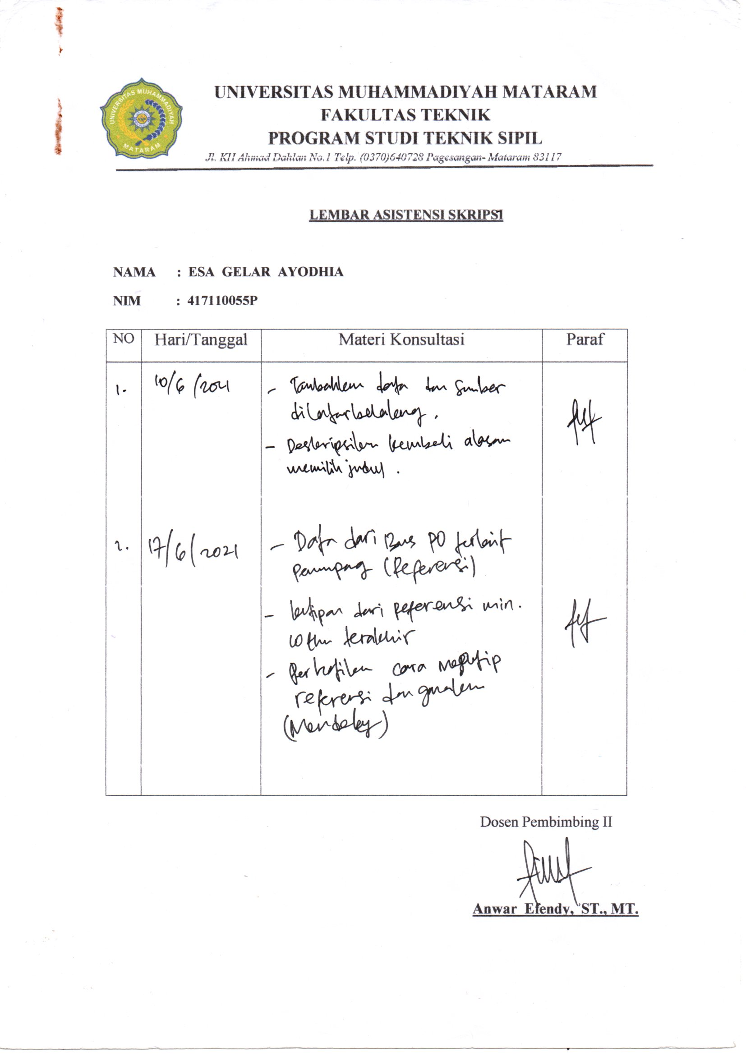
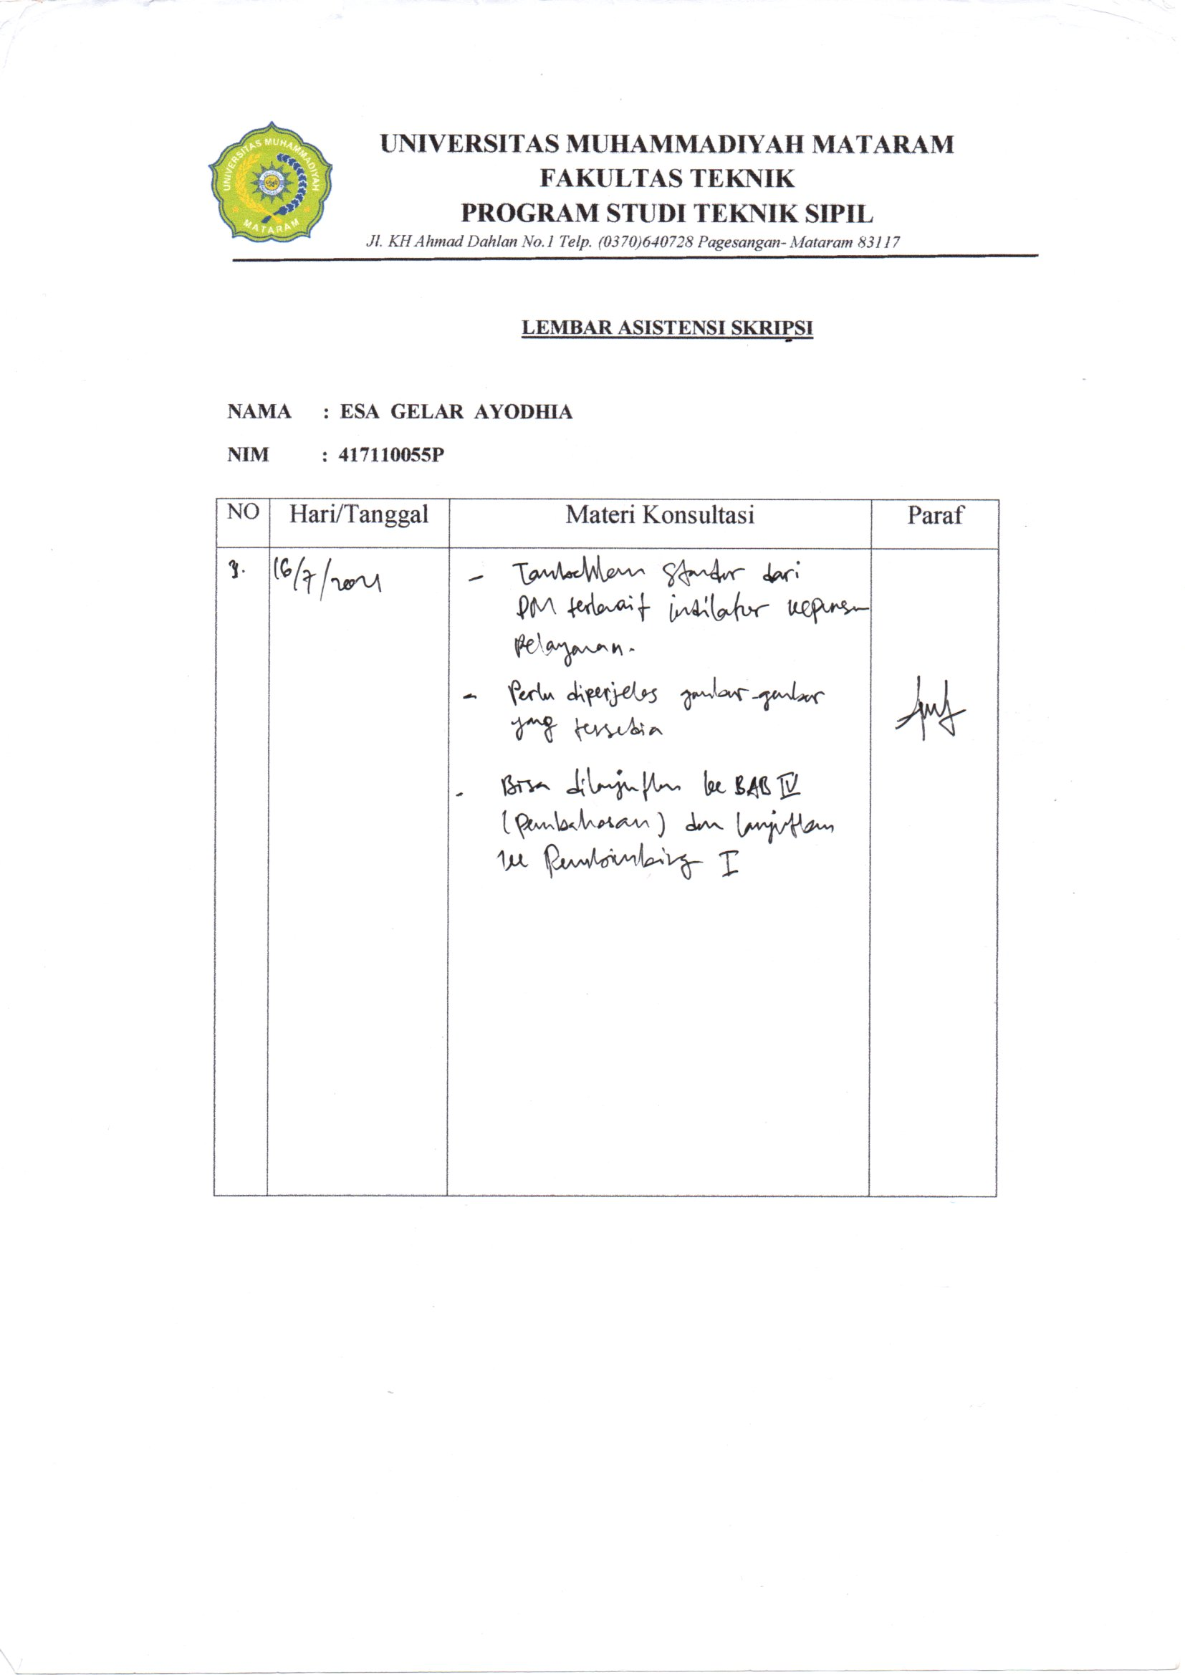
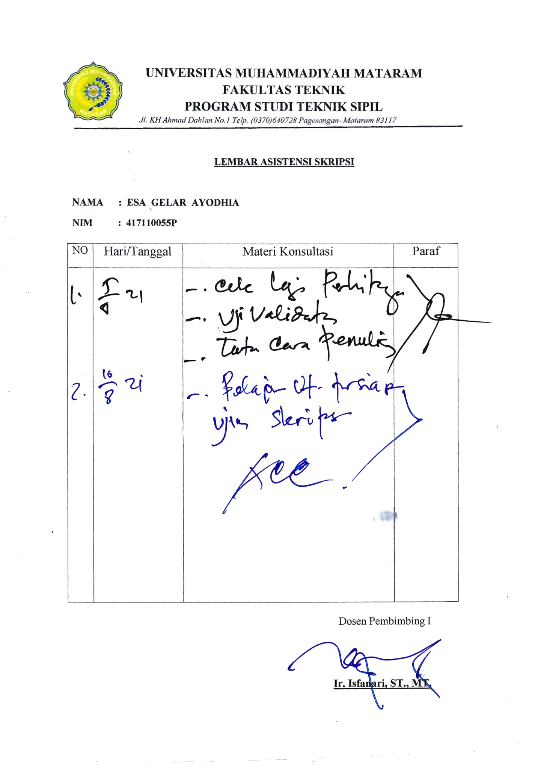

LAMPIRAN VII
SURAT DOSEN PEMBIMBING SKRIPSI
DAN SURAT PENELITIAN

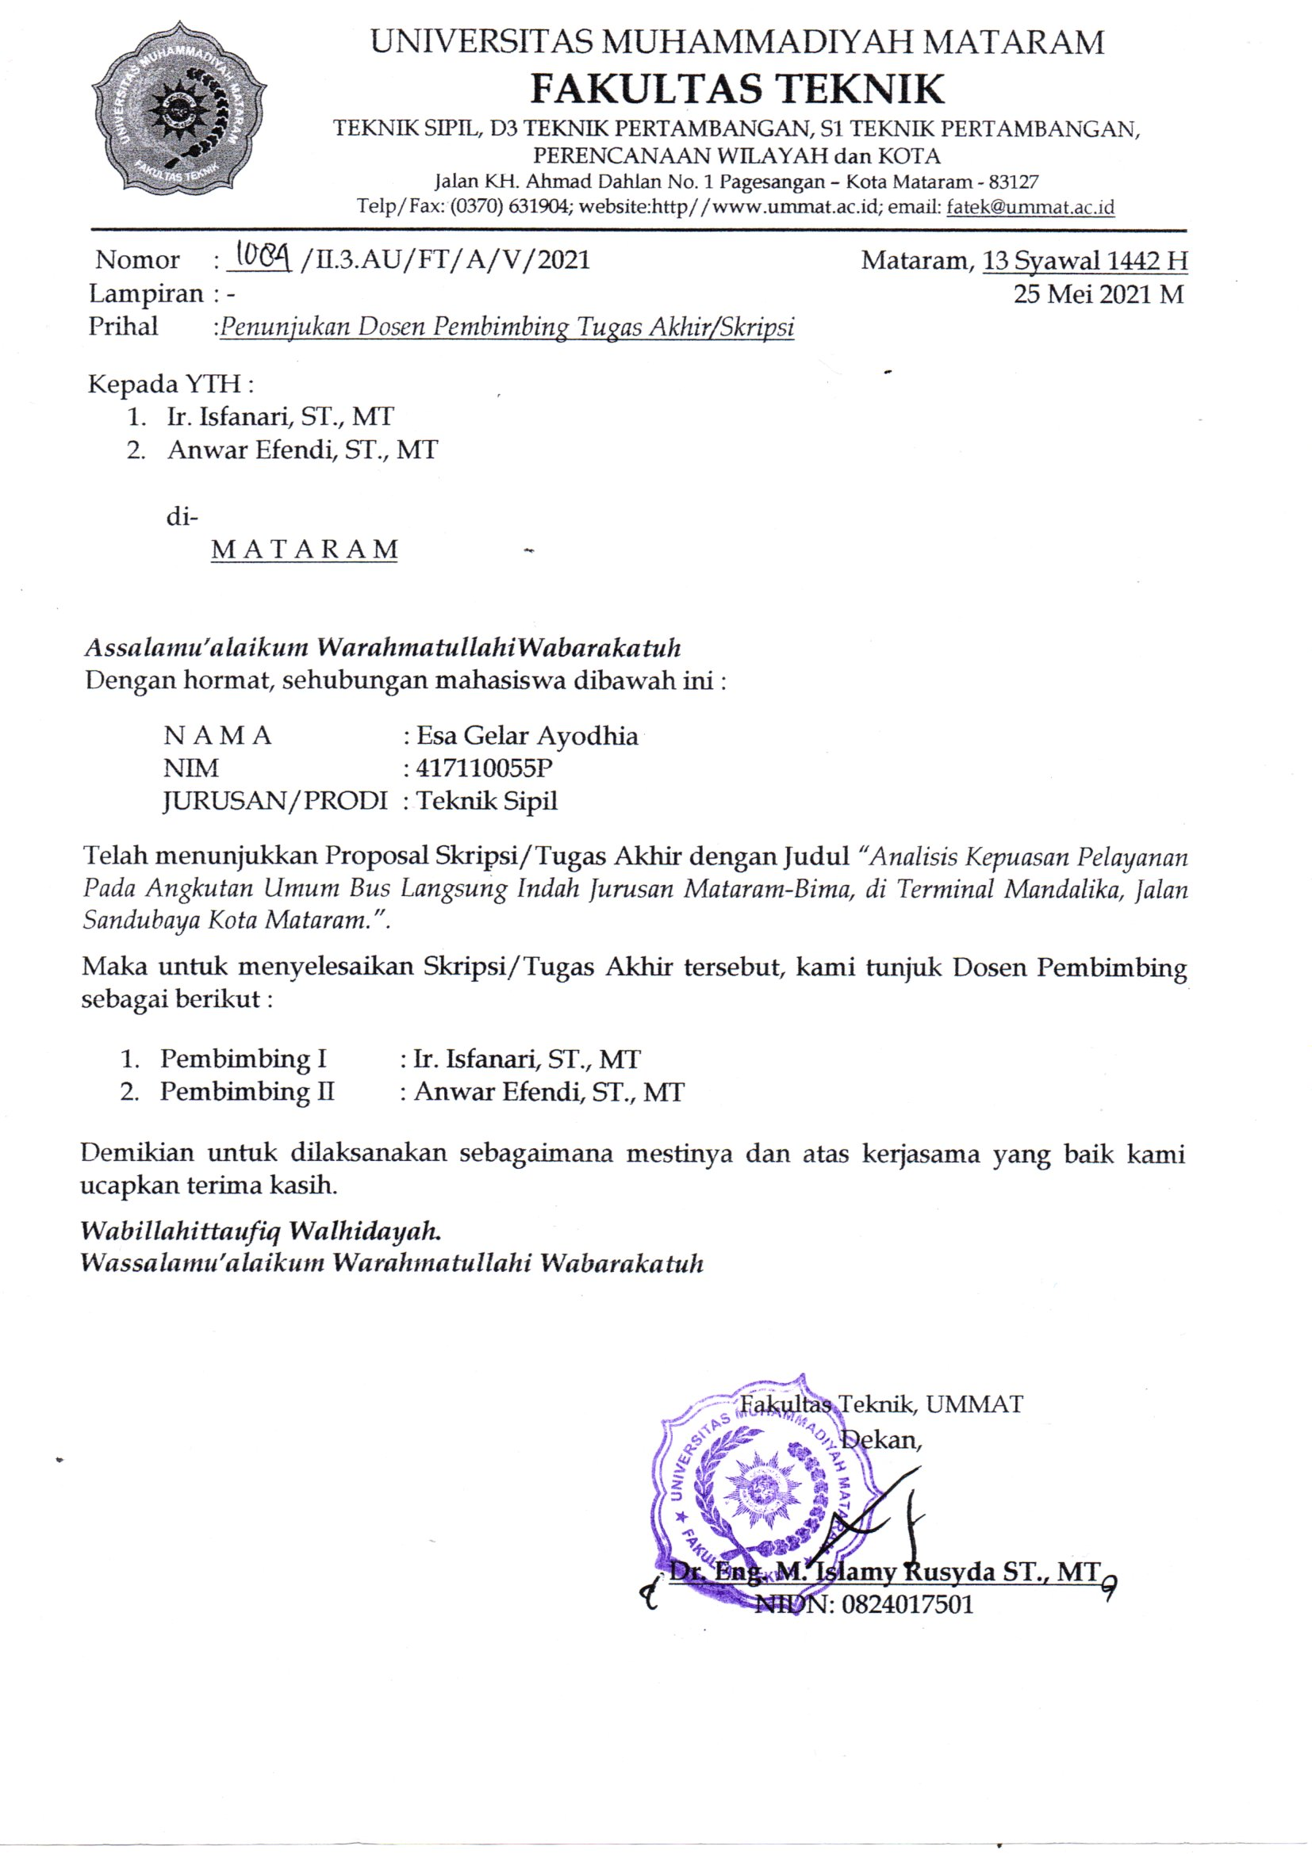
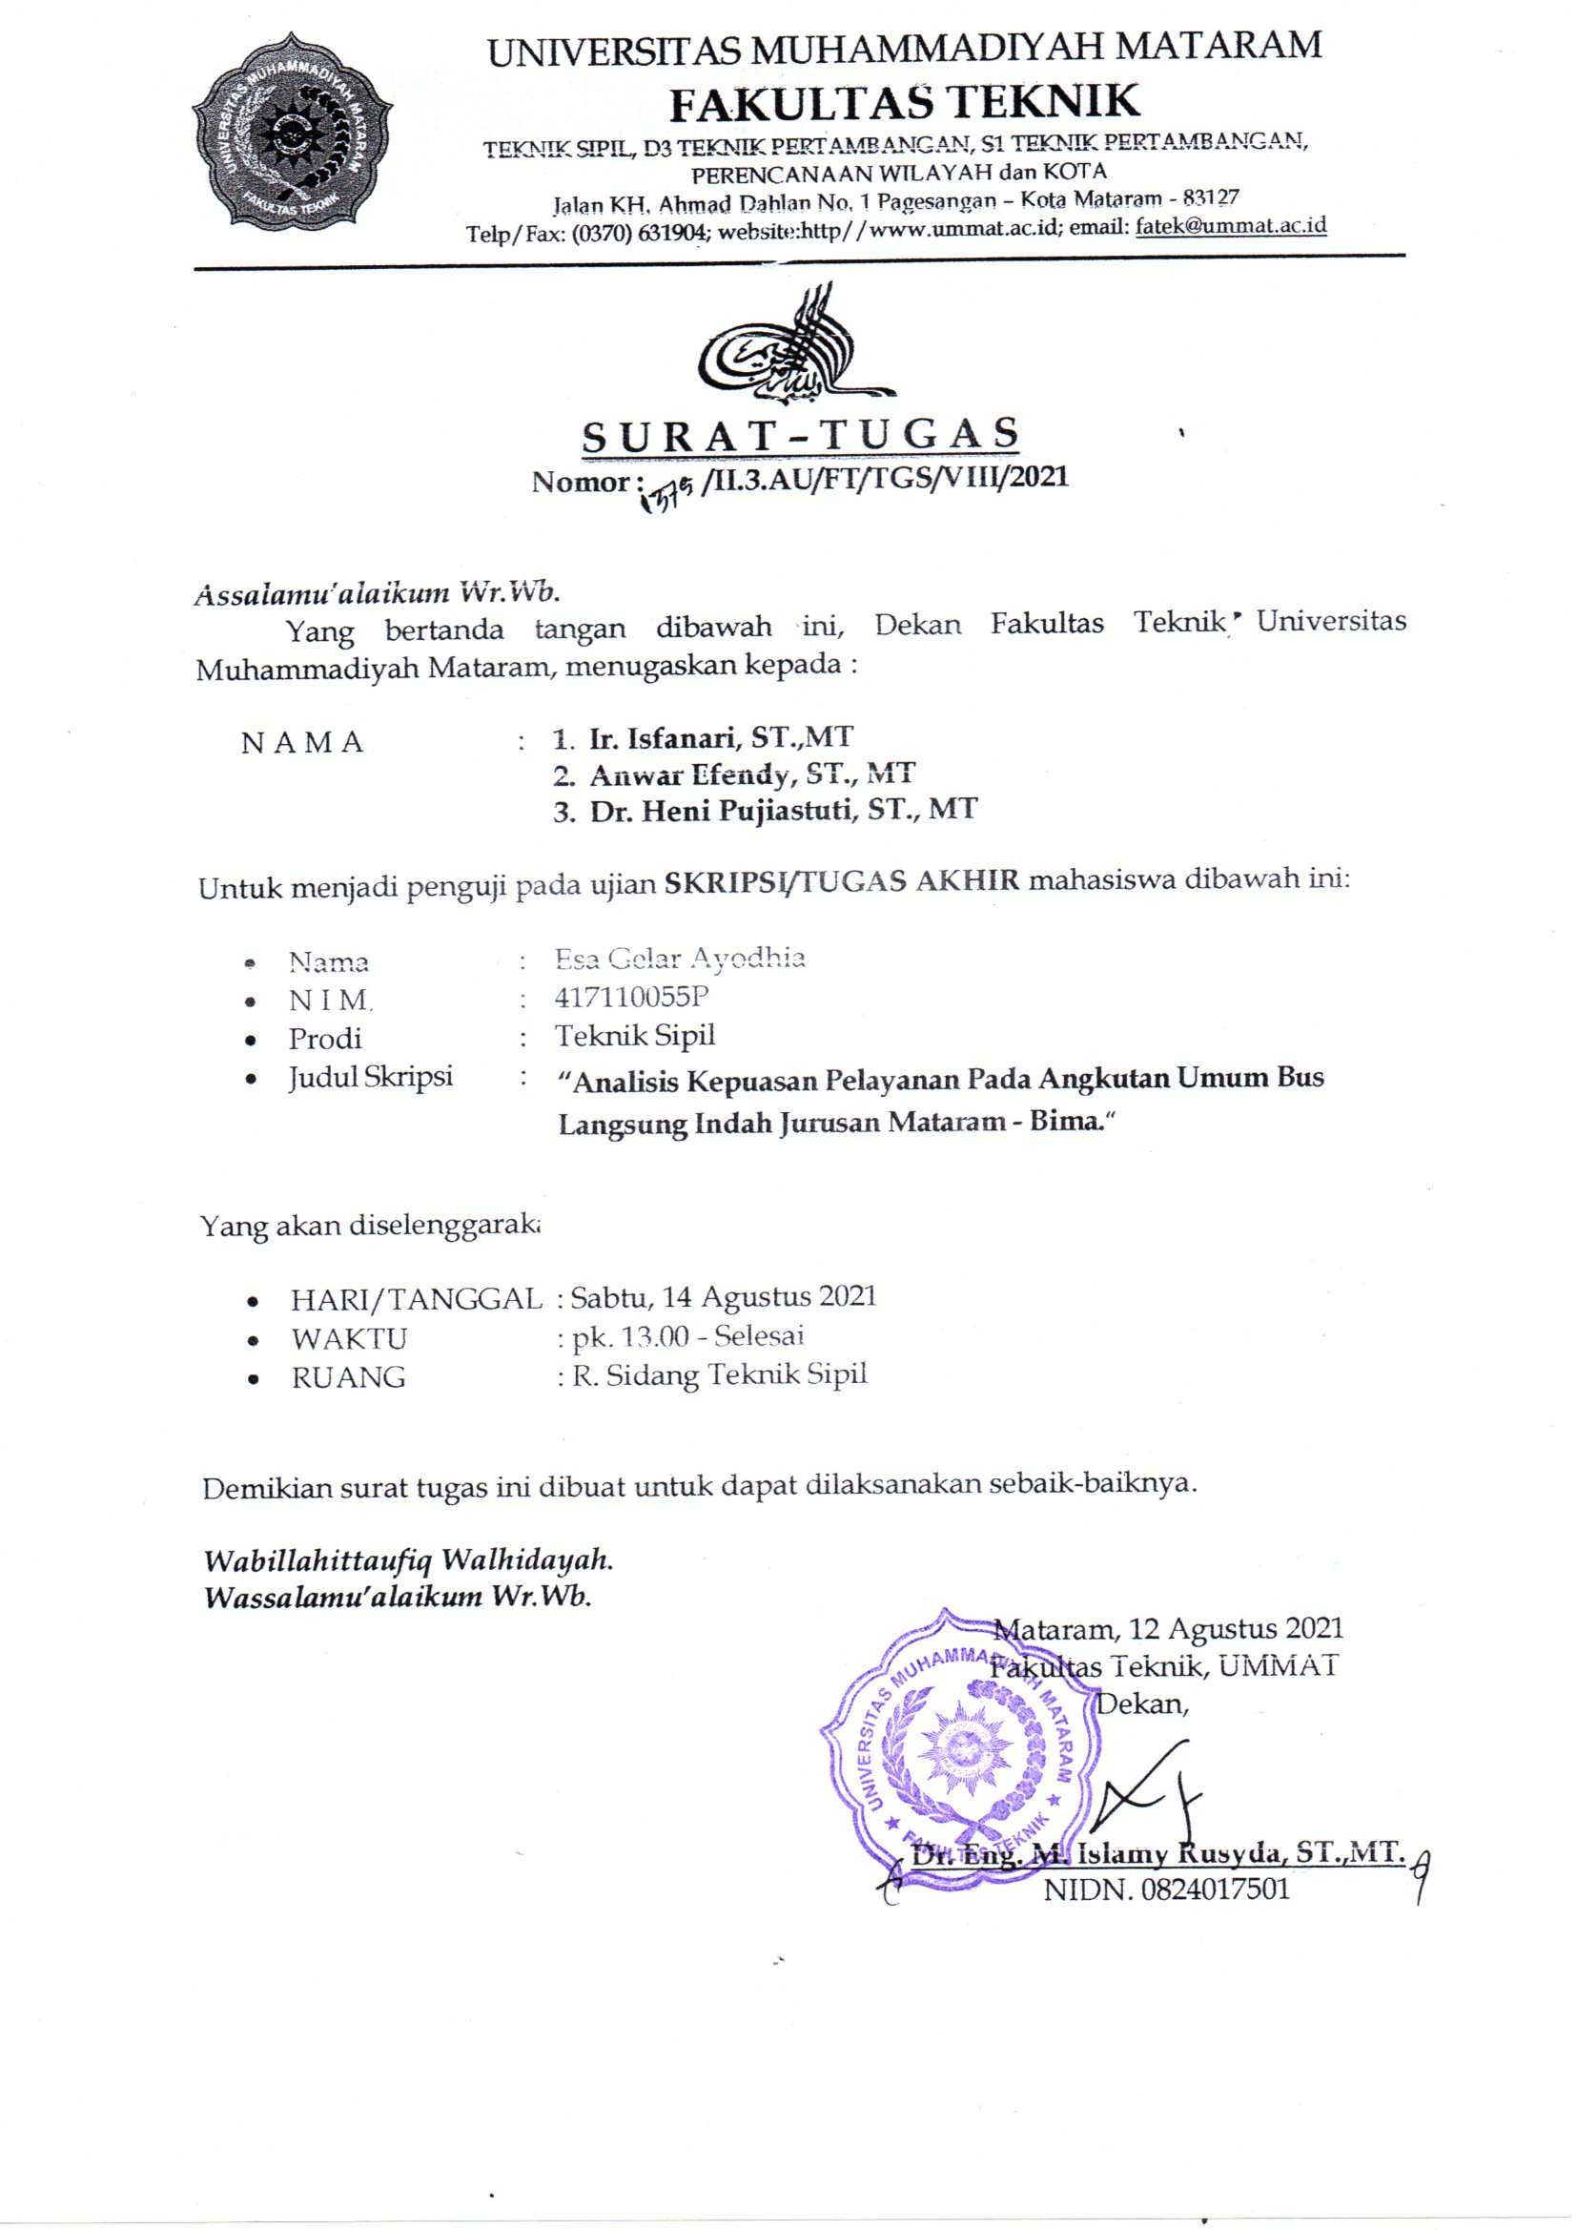
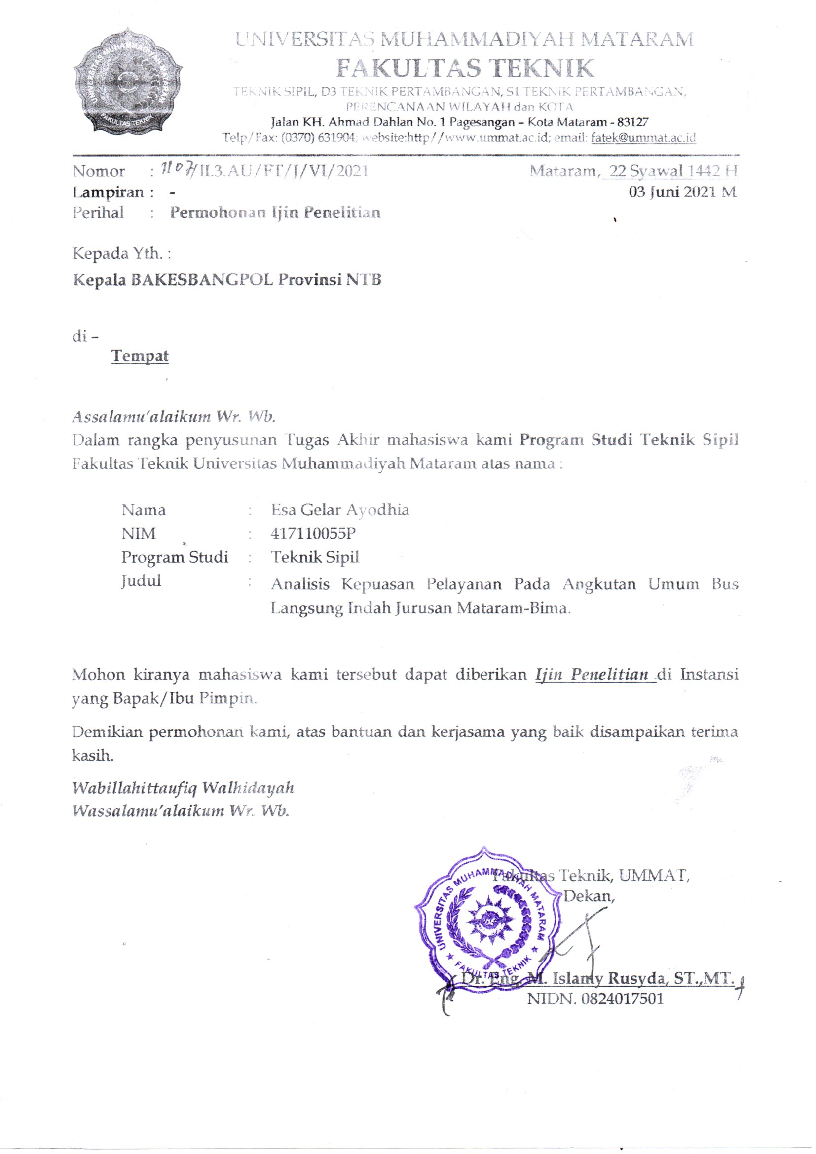
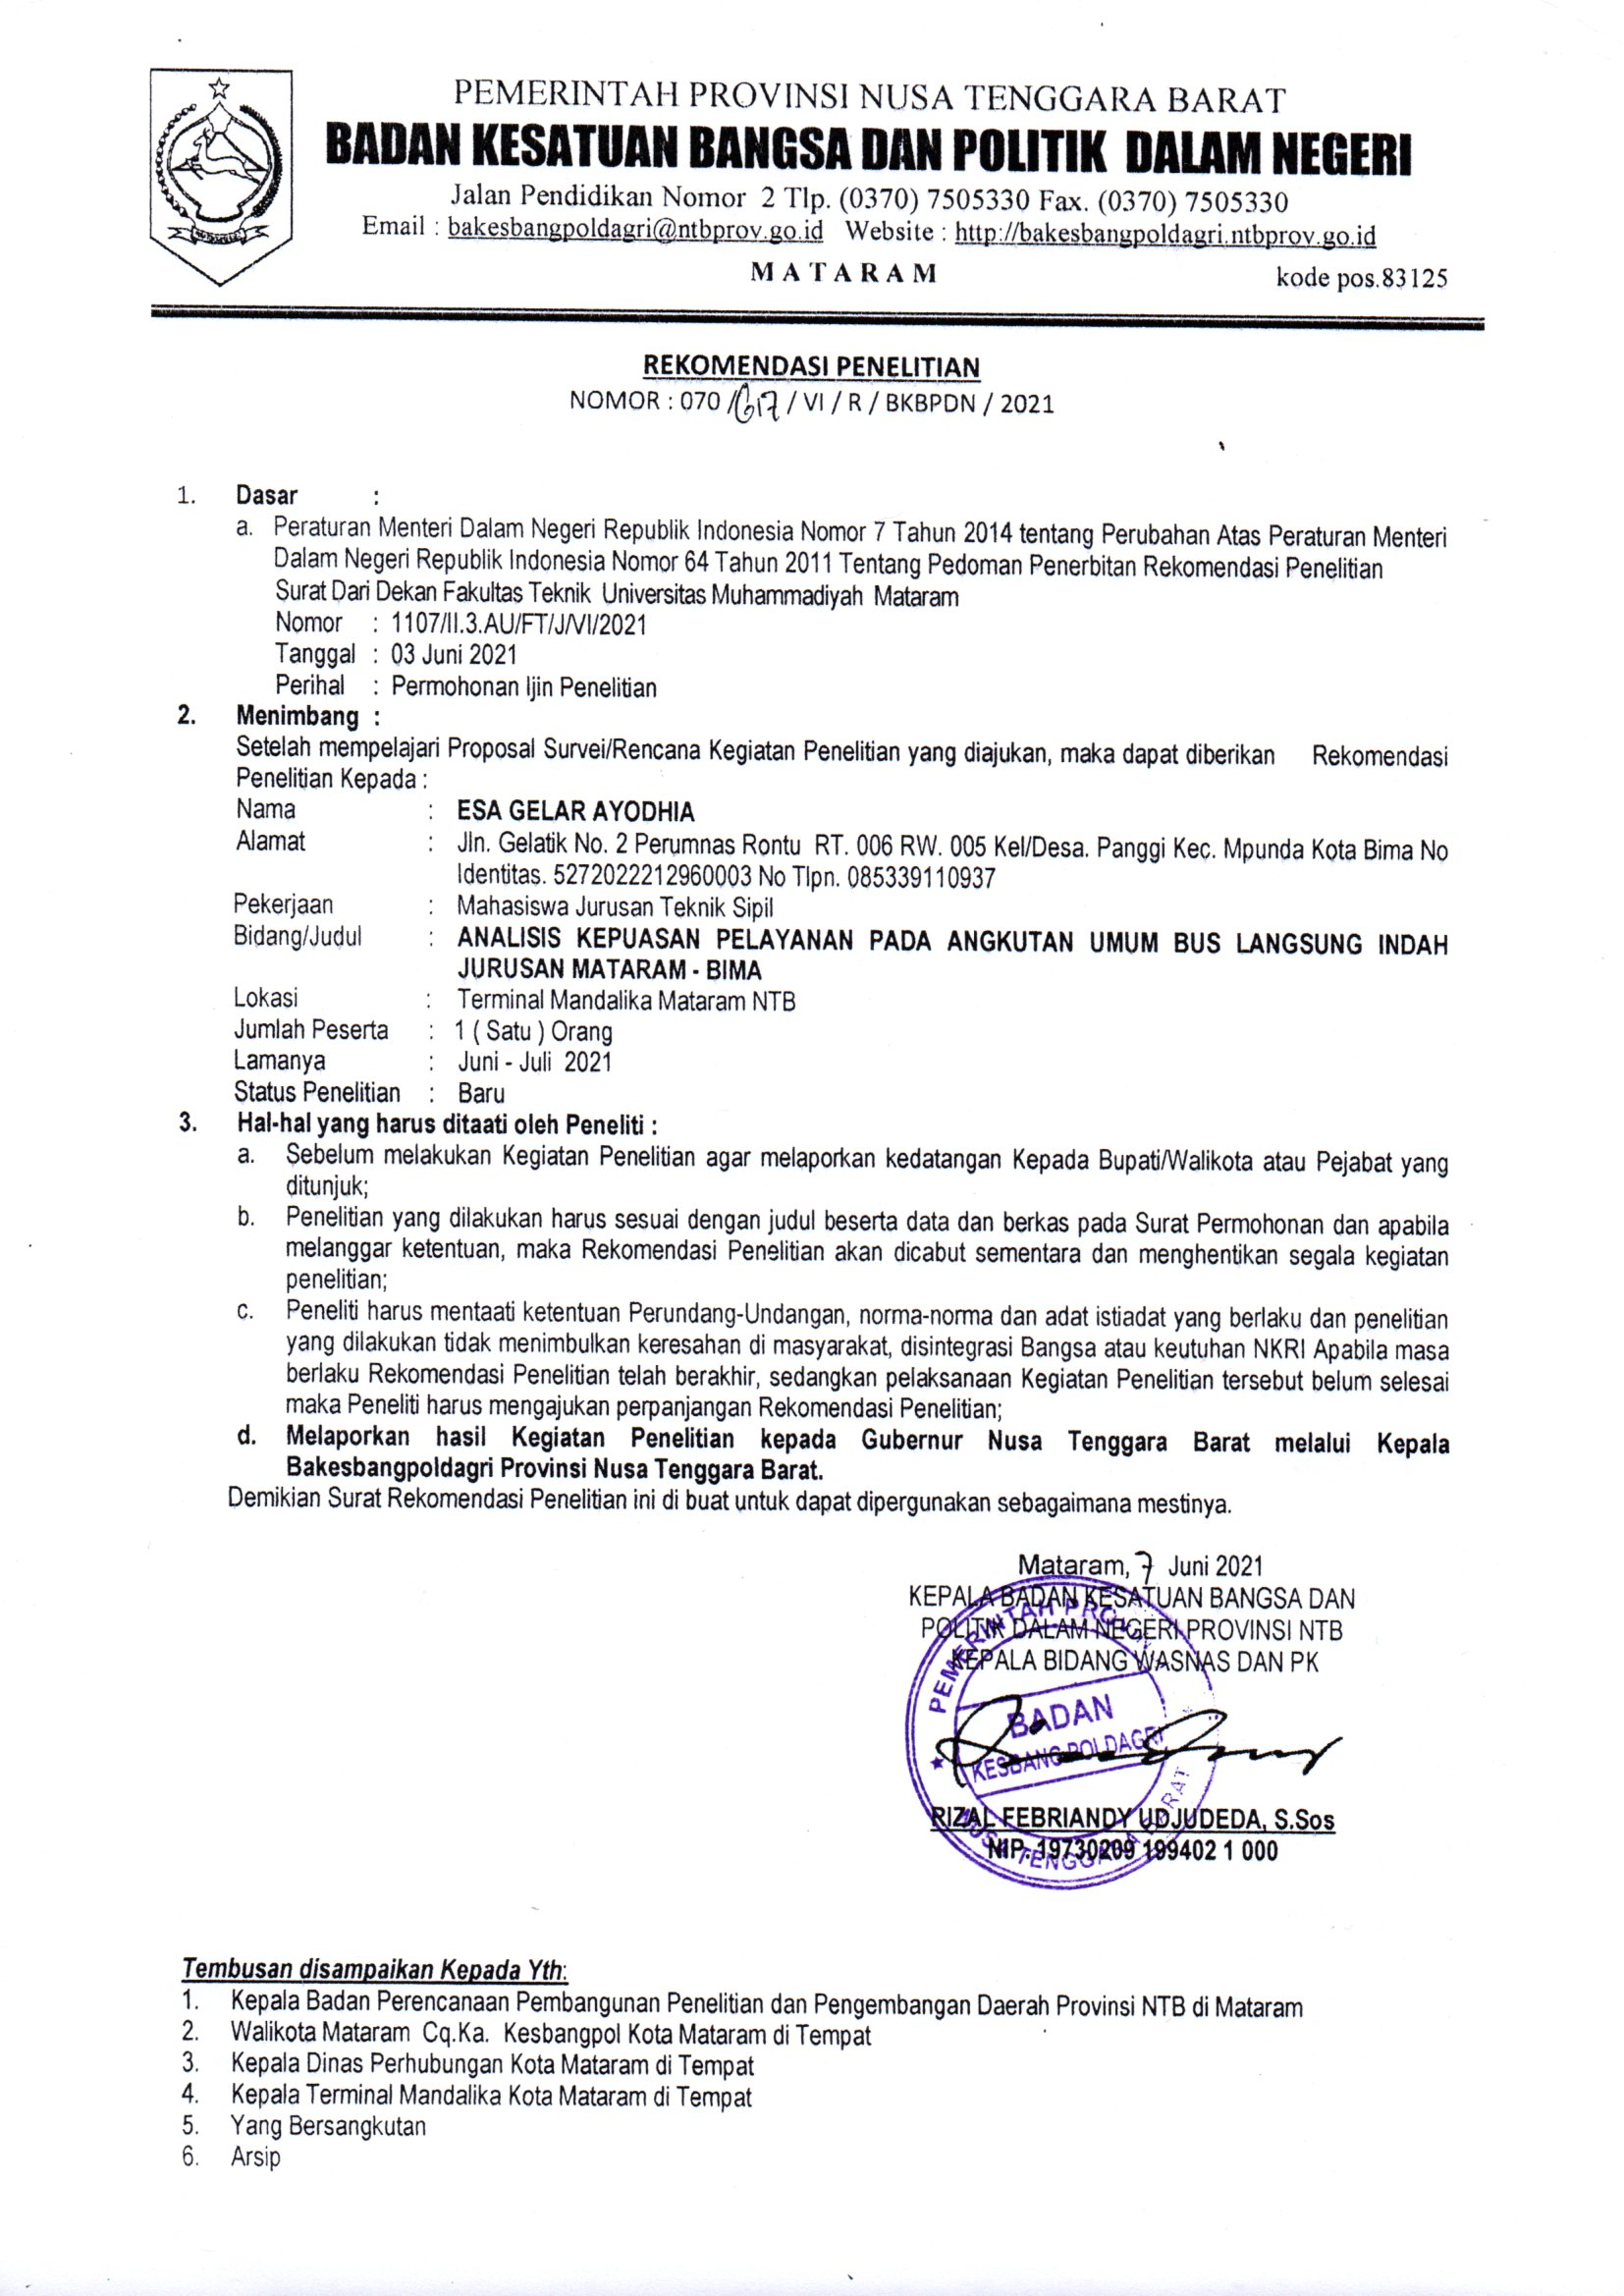

LAMPIRAN VIII
DOKUMENTASI

DOKUMENTASI

