AN ANALYSIS OF THE LINGUISTIC REALISATION OF AGENCY
IN THE NARRATIVES OFFIRST- YEAR STUDENTS
ON MUHAMMADIYAH UNIVERSITY OF MATARAM
IN ACADEMIC YEARS 2019-2020

A THESIS

Presented as A Partial Fulfillment of the Requirements for the Bachelor Dgree of Education in English Language Teaching

By
ROSLINDA NONA HAMUN TATUT
116120013

ENGLISH EDUCATION DEPARTMENT
FACULTY OF TEACHERTRAININGANDEDUCATION
MUHAMMADIYAH UNIVERSITY OF MATARAM
2020
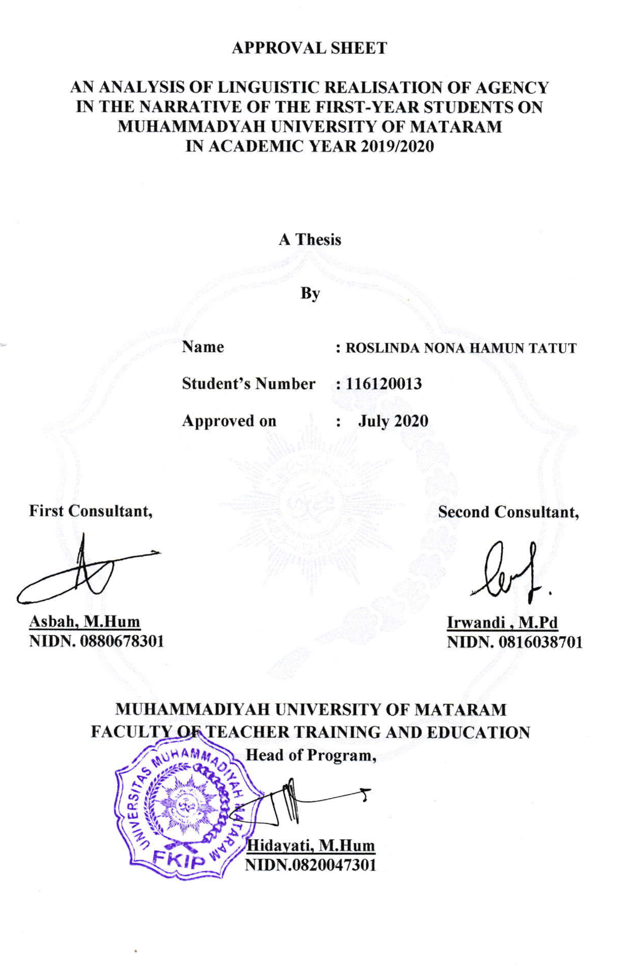

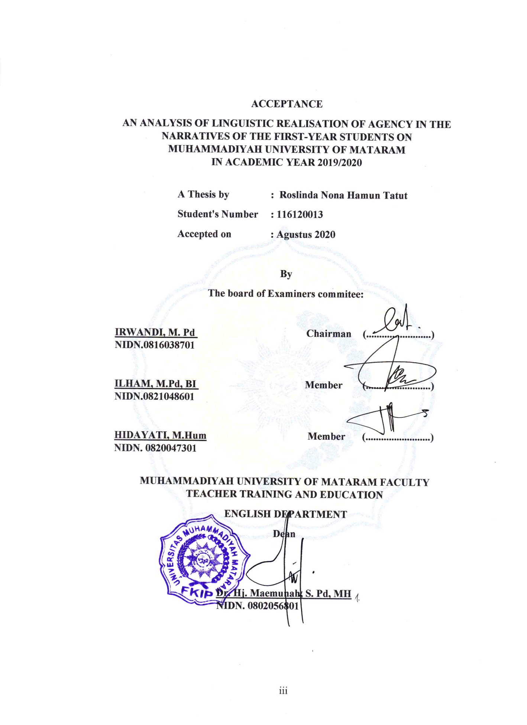

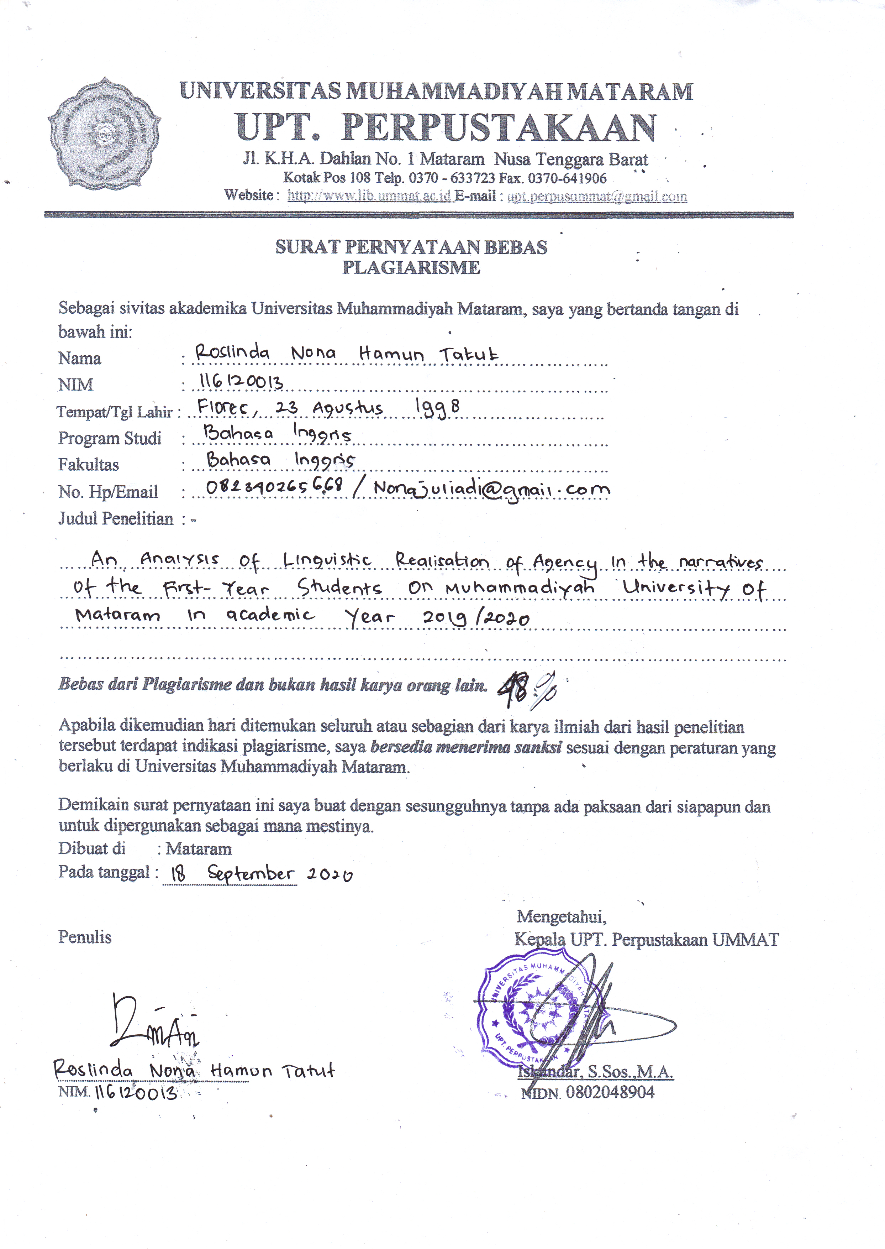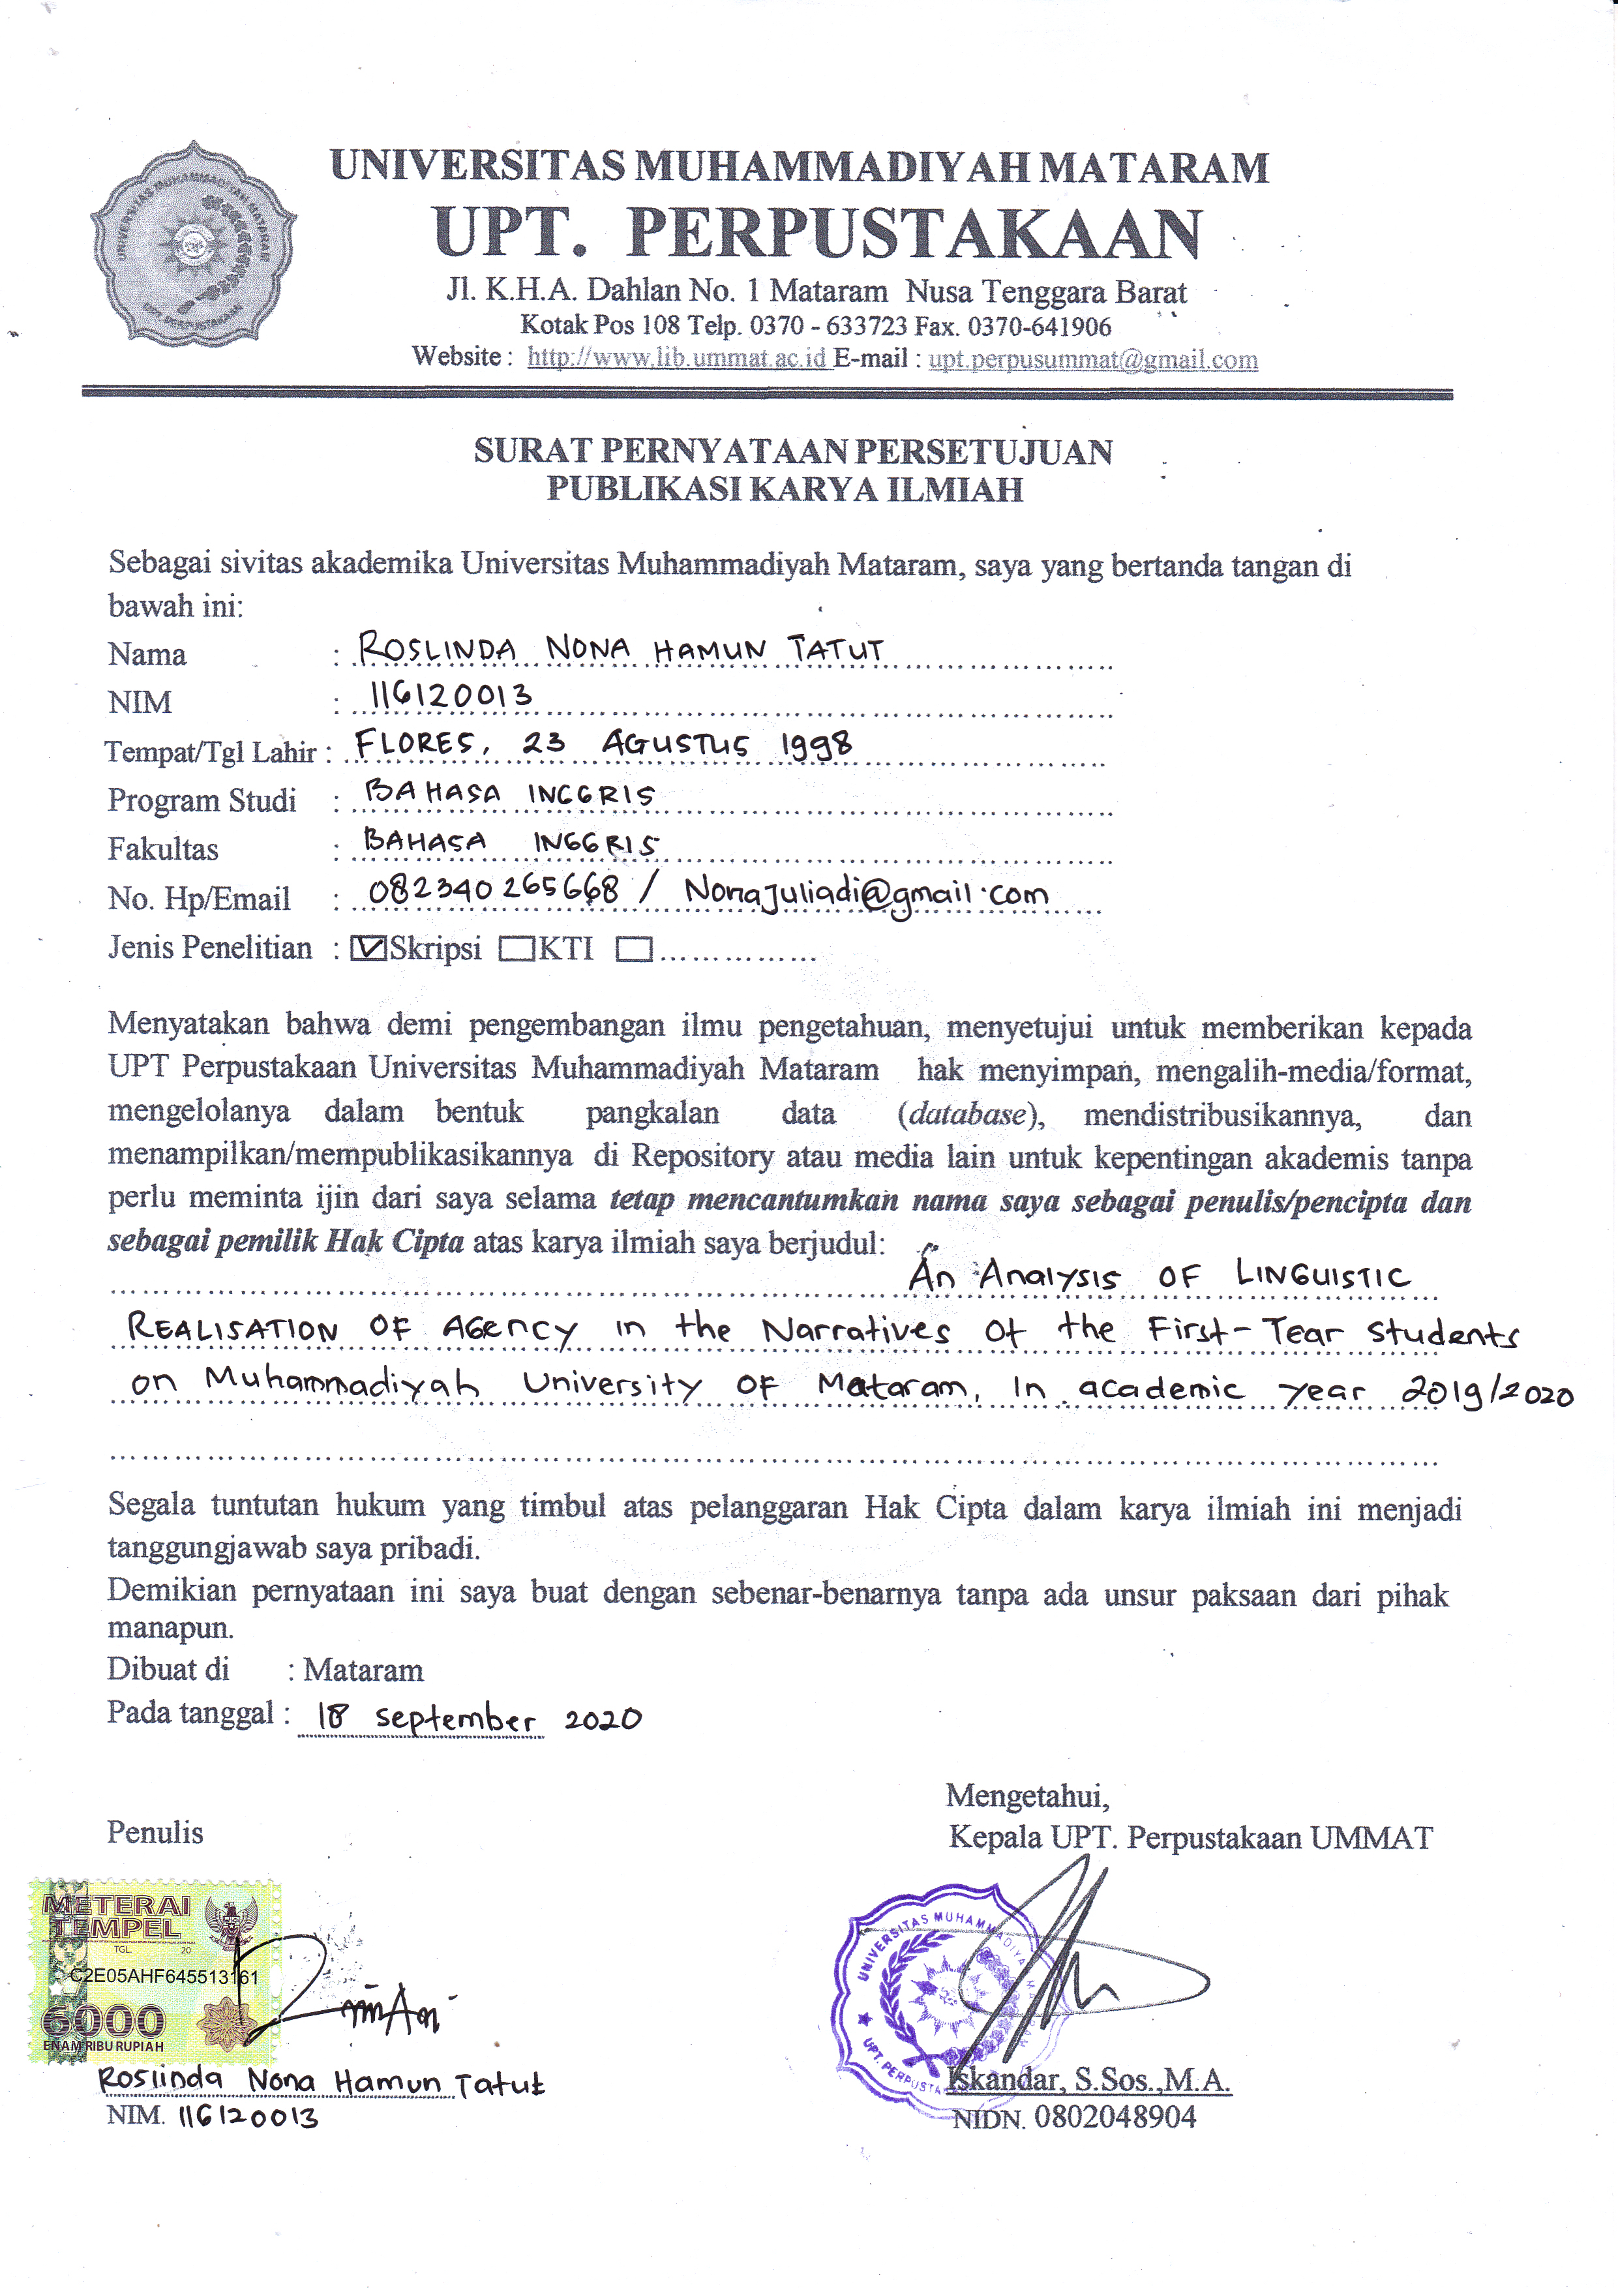
MOTTO

I ALONE CANNOT CHANGE THE WORLD BUT I CAN CAST A STONE ACROSS THE WATER TO CREATE MANY RIPPLES

- Mother Teresa -

ALWAYS A STEP AHEAD

- St. Familia -

DEDICATION

I dedicates this thesis for :
- To Almighty God which has given guidance and blessing.
thanks for rise me when I am down.
- To My beloved parent, my father Hubertus Hamun Tatut (RIP) and my mom Elisabeth Tatut who have given me lots of moral support, motivation and prayer for my success. Thanks for your sacrifice to looking after and protecting me until this success.
- To Sigit Juliadi Klau who always be with me, given me inspiration to accomplish this thesis. Thanks for your time for me
- To My Five brothers who always support me. Thank you so Much
- To all My friends who given me advisee. Thank you

DECLARATION

The autographed below, I am the student of English Departement , Faculty of Teaching Training and Education, Muhammadiyah University of Mataram State that :
Name : Roslinda Nona Hamun Tatut
Nim : 116120013
Address : Manggarai, Flores, NTT.

The researcher certifies that the thesis entitled “An Analysis of Linguistic Realisation of Agency in the Narratives of the First-Year Students on Muhammadiyah University of Mataram in Academic Year 2019/2020” presented as a fulfilment for the requirement in bachelor degree in my own work.
Except where otherwise acknowledge and this thesis has not been submitted for the higher degree Institution or University

Mataram, Agustus 2020
The Researcher

Roslinda Nona Hamun Tatut
116120013

ACKNOWLEDGEMENT
Thanks to Almighty God Jesus Christ who given blessing and holy grace to complate this undergraduate thesis, entitled “ AN ANALYSIS OF LINGUISTIC REALISATION OF AGENCY IN THE NARRATIVES OF THE FIRST-YEAR STUDENTS ON MUHAMMADIYAH UNIVERSITY OF MATARAM IN ACADEMIC YEAR 2019/2020” This thesis is presented to fulfil one of the requirements in accomplishing the S-1 English Department Faculty of Teacher Training and Education Muhammadiyah University of Mataram.
In this occasion,with great humility the researcher would like to thank you to all those who have given me helped and guidence so that this thesis can be accompished. Completion of writing of this thesis, the researcher would to thank to:
- Dr. H. Asyrad Abd. Gani, M.Pd as a Rector of Muhammadiyah University of Mataram.
- Dr. Hj. Maemunah, S.Pd., MH as the Dean of Faculty of Teacher Training and Education.
- Hidayati, M.Hum as the Head of English Department and for encourangement and important advise for the completion of this thesis.
- Asbah, M.Hum, my first consultant for criticism and suggestion
- Irwandi, M.Pd, my second consultant who gave me a valuable guidance and encouragement in writing this thesis.
- The second semester students who participated and has been helping the researcher in writing this thesis.
The researcher realizes that in writing this thesis, numerous people with their help, ideas, advice, support and suggestion. So, this thesis could be accomplished. Therefore, the writer would like to express sincerely thanks to them individually, particularly all English Lectures and all my classmates.
Mataram, Agustus 2020
Roslinda Nona Hamun Tatut
NIM.116120013

TABLE OF CONTENTS

TITLLE PAGES i
APPROVAL SHEET ii
ACCEPTANCE iii
MOTTO iv
DEDICATION v
DECLARATION vi
ACKNOWLEDGEMENT vii
TABLE OF CONTENTS viii
ABSTRACT xi

CHAPTER I INTRODUCTION
  - Background Of The Research 1
  - Research Question 4
  - Scope Of The Problem 4
  - Purpose Of The Research 4
  - Significance Of The Research 4
  - Definition Of Key Term 5

CHAPTER II REVIEW OF RELATED LITERATURE
  - Definition Of Linguistic 6
  - Branches Of Linguistic 7
2.3.1 Phonology 7
2.3.2 Morphology 7
2.3.3 Syntax 8
2.3.4 Semantic 8
2.3.5 Sociolinguistic 10
2.3.6 Psycholinguistic 11
2.3.7 Anthropolinguistics 11
2.3.8 Stylistics 11
2.3.9 Philogy 12
2.3.4 Dialectology 12
  - What Is Linguistic Realisation 13
  - Narratives 14
    - Definition of Narrative 14
    - Structure of Narratives 15
    - The Types of Narratives 16
  - Individual Agency 17
  - Previous Study 17

CHAPTER III RESEARCH METHOD
  - Research Design 19
  - Research Participant 20
  - ResearchInstrument 20
    - Questionnaire 20
  - Liguistics Analysis 21
    - Data Reduction 21
    - Data Display 21
    - Conclusion Drawing/Verification 22
  - Conclusion 22

CHAPTER IV FINDING AND DISCUSSION
  - Research Finding 24
    - Students' Motivation and Reason Choosed English Department 24
    - Students' identities 25
    - Narrative Analysis 25
      - Structural Analysis 25
        - IR’s Narrative 26
        - RA's Narrative 28
        - MA's Narrative 28
        - RY's Narrative 31
        - RM's Narrative 33
        - SA's Narrative 34
    - Themathic Analysisis 35
      - Theme : The construction of university 35
      - Theme : Education 37
      - Theme : Working-Hard 38
    - Lingustic Analysis 39
      - Metaphor 39
      - Modality 40
      - Pronouns 41
  - Discusses 42

CHAPTER V CONCLUSION AND SUGGESTION
  - Conclusion 45
  - Suggestion 46

BIBLIOGRAPHY
APPENDICES

Tatut Roslinda.116120013. AN ANALYSIS OF LINGUISTIC REALISATION OF AGENCY IN THE NARRATIVES OF THE FIRST-YEAR STUDENTS
ON MUHAMMADIYAH UNIVERSITY OF MATARAM IN ACADEMIC YEARS 2019/2020

ABSTRACT

Higher education is a place where students continued their education to a higher level. Many students' of the first-year feel difficulties to transition to university.This research aims to analyze how linguistic devices such as Metaphor, modals and pronoun influnced students' agency. Then, this research analyze about structural analysis based on students' narratives. It is purposed how far students’ in Muhammadiyah University of Mataramrealize about their past event who influenced themselves and how their agency. So, they can participate well in build the University because students’ is an individual agent in taking choiches and decision. It depens on them Active or Passive agent they choosed. In this reaserch, used qualitative case study and adopted narrative analysis as an approach. About Six participants who participated, especially the second semester students, Faculty of Teacher Training and education, English Education Department. Through of the analysis of student's narratives in terms of structure, themes and linguistic devices, the result of this research that the student realize their past event before they coming and choosed Muhammadiyah University of Mataram. From the student’s narratives they came from streesfull social conditions. But they can construct theirselves and they are active agent in their taking choiches and decisions.

Key word : Higher Education, Motivation, Agency, Choiches, Decision

Tatut Roslinda.116120013. AN ANALYSIS OF LINGUISTIC REALISATION OF AGENCY IN THE NARRATIVES OF THE FIRST-YEAR STUDENTS
ON MUHAMMADIYAH UNIVERSITY OF MATARAM IN ACADEMIC YEARS 2019/2020

ABSTRAK

Perguruan Tinggi merupakan sebuah tempat dimana mahasiswa/I melanjutkan pendidikan mereka ke jenjang yang lebih tinggi. Banyak mahasiswa/I dari tahun pertama menghadapi banyak kesulitan untuk melakukan suatu transisi ke sebuah Unuversitas. Study penelitian ini bertujuan untuk menganalisa bagaimana realisasi ilmu kebahsaaan(linguistics) seperti; metaphor, modals dan pronoun mempengaruhi agency dari setiap mahasiswa/I. Kemudian, study penelitian ini menganalisa tentang structural analysis berdasarkan narrasi mahasiswa/I. hal ini bertujuan untuk mengetahui seberapa jauh mahasiswa/I di Universitas Muhammadiyah Mataram realize tentang kejadian-kejadian di masa lampau mereka yang telah mempengaruhi diri mereka dan agency mereka. Dengan hal ini, mereka dapat berpartisipasi dengan baik dalam membangun Universitas karena kita ketahui bahwa mahasiswa/I adalah Idividual Agent dalam mengambil pilihan dan keputusan dalam kehidupan mereka. Permasalahan tentang agency ini tergantung pada mahasiwa/I itu sendiri, Activ or passive Aget mereka pilih.
Studi penelitian ini menggunakan metode kulitatif dan narrative analysis sebagai pendekatannya.Terdapat 6 partisipan yang berpartisipasi, khususnya mahasiswa/I semester 2, Fakultas Keguruan dan Ilmu Pendidikan. Melalui, narrative analysisseperti struktur analisis, thema dan juga linguistics komponen. Hasil dari studi penelitian ini ialah mahasiswa/I yang dating dan memilih kampus Muhammadiyah dan memilih jurusan Bahasa Inggris, mereka-mereka ini dating dari status social yang berbeda dan memiliki kondisi Stressfull, tetapi mereka dapat bertahan dan mampu membentuk diri mereka sendiri dan mereka juga merupakan agen yang aktif dalam memilih dan mengambil keputusan dan kemauan mereka.

Key Word : Pendidikan Tinggi, Agency, Pilihan, Kemauan

CHAPTER I
INTRODUCTION

  - Background of the Study
Higher education is a place where students continued their education to a higher level. An education system must provide comfort for its students. Basically, students who want to continued their education in higher education has backgrounds and social status that are different from other students. These students came from different races, ethicizes, religions, cultures and languages. It can be possible there will be a distinction between these students, both according to race, religion, culture and even their social status.
In terms of this distinction, many students are unable to participate well in the scope of tertiary institutions. This became a big problem for students and university because students have been lack of confidence to participate properly due to differences in backgrounds between students themselves. In previous studies, for example (Gorski 2010, p. 1) said that there were some students who did not / underachiever always be associated with their social status. This is a matter that many of us encounter among education, where there will be several parties who see and assess a student's achievements or achievements based on social status. South African, has been conducted education systems that ensures that there is no distinction of intermediate students, for example, the apartheid racism among students and colleges (Martin. 2019, P.8). Indonesia also has case like this, where racism is a problem with students from eastern Indonesia (Papua).
Those case very disturbing and influential students and can affect learning achievements and was damaged their motivation and reasons to participate actively to build yourself and the surroundings environment. In this case, Student's beliefs influenced how the students confidence took decisions and choices, because student's beliefs have to important role in learning process. According to Virginia (2003, p. 2) stated that Belief itself can be defined as "Psychologically held understanding promises or propositions about the world that are felt to be true".
1
It means that beliefs are something that we can not see and touch but beliefs are something in your mind that you fell true. Also, beliefs mean that the root of our thought. It can be influenced the way we think about something. Seems like when the students choosen their decisions or choices in their life, such as : what is, vision or something who make them changed. It all happened because they had beliefs in their own self. How these beliefs become an important thing to get what they want at this moment or for the future. All of it depend on their selves.
Like past researcher Agus Ruswandi (2018) in his research related to students' in choosing a study program, namely PG PAUD Unius, said that there were several s / reasons for students based on the results of narrative writing about themselves. There are 3 reasons / s that they write: 1. Students who choose the program only because they have a fondness for children. 2. students who want to find a diploma and those who are 3. true students who want to seek knowledge and get good jobs in the future. It can be concluded that, from the cases above it can be seen that there are several reasons why students continue their education. this can trigger the participation of students in developing themselves and others.
The researcher see that whether the / reasons they bring, making them agents who are passive or active in building, forming and developing themselves and the environment because of the problem of student agencies, it becomes an interesting thing to study. Research on student agency can be done by asking students especially FirstYear at Muhammadiyah University to write down narratives based on their own journey / life experiences. With linguistic Realisation analysis because linguistic will be showing and can be make an interpretation about students narrative. For example, students narrative who has hidden-meaning. At the end of this study, students' narratives will be analyzed in a structural manner based on the narrative structure and what linguistic tools are often used by students from their writing especially society-language. It aims at whether the features written by students are useful or function as passive agents or active in their own choices and decisions. Known the concept of Linguistic Agency (also called 'Agentivity' or 'Intimacy') refers to the linguistic marking of different in perspectives in which represented characters are viewed as relating to an object and to other characters in the (represented)_world_(http://www.econgeography.org/~mbamberg/EncyclopediaEntries.html.
Typologically, languages ​​will offer the different lexical and grammatical choices for characters and event construction and by use of such choices speaker signal different perspectives (and position selves and others). It means that between 'person' and language has a correlation. Because, language that human used in their narrative, will be make an interpretation or perspective about the choices or decisions by character based on own Experience. This is why, the researcher want to searching for how student make a point of view about their event construction of everything of their journey of life, which they are characters in their own story (Narrative) that can construct their self or other. An Action shown by character can interpreted what they want to do or their wishes. The researcher reason to choose this title because there are many students are not realize or awareness about their life, especially the students coming to university. It is way the researcher really interesting about that case. The researcher want to know how the students not only aware or realize but how they can constructtheir selves by their narrative with use Linguistic Realization and adopted Narrative analysis. So, from the case and information that the researcher has offered above, the researcher is very interested in taking the title "An Analysis of Linguistic Realisation of Agency in Narratives of the First-Year students on Muhammadiyah University of Mataram in Academic 2019/2020"

  - Research Question
Based on the case above, every student who has came to University has an own experienced,reason and event to constructedthemselves and their environment because their self is an agent in took their choices and decision. There are questions that the researcher asked:
- How do students construct themselves and others in their narratives about their lives for coming to Muhammadiyah University of Mataram?
- How students' motivation and reasons influenced their selves to choosed English Departement?
  - Purpose of the Study
Based on the research question above, the purposes of the study are:
- To analyze how students construct themselves and other in their narratives about their lives for coming to Muhammadiyah University of Mataram
- To analyze how students' motivation and reason influencedtheir selves to choosed English Department

  - Scope of the Study
In this research, the researcher have beenlimited the discussion of the problem. The researcher used the second semester students of the Muhammadyah University of Mataram, Faculty of Teacher Training and Education. Especially the English departement and this research foccussed on lingustic also narrative analysis based on Labov (1967 and 1972) It purposed to avoid misinterpreted and misunderstanding for the discussion because the broadness of the problem.

  - Significance of the Study
1. Theoretically
- Enrich the theory about linguistic and Narrative analysis (Labov. 1967 and 1972). Especially the structure of students' narratives.
2. Pratically, this study will hopefully can be of some practical implication such as:
- For the students in university especially in second semester, it can be motivated for them to improving their skill in looking their existence in their line as an agent and also it can make student improve their writing.
b. For the university, the result can be the data to analysed the ability of students in make a narrative and can get a new information about linguistic realisation of agency from their narratives.

  - Definition of Key Term
In other to avoid misunderstanding, some terms used in this research are clarified follows:
- Realisation refers to the process by the which some kind of a surface representation is derived in which some abstract object of linguistic analysis comes to be produced in actual language (Martin, 2019).
- Linguistic refers to deals with human language as universal and recorgnizeable part of human behaviour and human capabilities (King T. Nass, 1984).
- Agency refers to the capacity of individuals to act independently and to make their own choiches (Duranti, 2004).
- Narrative refers to how someone telling his/her story of life (K. Stapleton, 2017).

CHAPTER II
REVIEW OF RELATED LITERATURE

In this chapter consist of theoretical found the researcher explained about the defenition of linguistic, brench of linguistic, narrative, structure of narrative, types of narrative, agency and pervious study.

  - Definition of Linguistic
Jirka Hanna (2011,p. 1) says that linguistic is the scientific of human language . It tries:
- First, to observe language and to describe them accurately
- Then, to find generalization within has been described
- Finally,to draw conclusions about general nature of human language.
Language are sets of sign. Signs combine an exponent (sequence of letters or sounds) with a meaning (Marcus Kracht, p.3). Language plays a great part in our life. Perhaps because of its familiarity, we rarely observe it taking rather for grantees as we do breathing or walking (Leonard Bloommfield.1933).
Bloomfield (1933, p .20-34) linguistic is science. like as physics and chemistry are part of science. In here, Bloomfield and Hanna want to tell us that linguistic is the part of science who must study deeply. Especially about the nature of human language. From the all the statement above, linguistic is the study of language and linguistic is a science, it means that the language cannot stand alone without another component of language itself. Linguistic is the way that the researcher can using to know and learn what all the component in language. Not only language. Linguistic study the internal and external aspect in language. Noam Chomsky assert that” Human brain is biologically programmed to learn language, so language faculty is innate” (Binoy Barman.2012,p. 104).
6
The researcher conclude that, we can learn language when our brain is connected or working.The language acquisition will saving in our memories. We need linguistic realisation, to make our self very aware how important language in our life and lived.

  - Branches of Linguistic
According to Coulmas (1998, p. 4) stated that linguistic was devided into two cathegories. They are Micro and Macro Linguistic. Micro linguistic that studied internal sctructure of language. Micro linguistic can be defined a board term convering the study of core levels of linguistic analysis, such as :
    - Phonology
Is a branch of language science that examines the hull of the sound. According to Keraf (1984, p.32) phonology is the part of lingustic who study about sound (language sound). Phonology is the field of linguistic to study, analyzes and discussed about the squence of sound. Etymologically, phonology formed by word 'fon' means sound and 'logi' means science (Chaer.1994: 102).
    - Morphology
Is the brance of linguistic that identifies the basic units of language as grammatical units (Veerhar. 1996, p. 97). According to Crystal (1980, p. 232-233) morphology is the grammar that examines the structure or form of words mainly through the use of morphem. In addition, the researcher can conclude that morphology is the structure and form of word in language or language, including inflection, derivation, and formations of the compounds. The basic level word are made "morphems", these are smallest units of meaning: roots and affixes (prefixs and suffixs). For example ' schoolyard ' is made of 'school' + 'yard’, 'makes' is modified from 'make' + 's',ect.

    - Syntax
is the study of the principles and processes by the which sentences are constructed in particular language. Noam Chomsky (2002, p.11) said that syntax the lesson/lecture on the princples and processes in which the sentences are arranged in specific language. Example a) while watching a movie, people who text on their phone are very annoying
b) People who text in their phone while watching a movie are very annoying. In sentence (a) is incorret syntaxsis becauce the phrase " While watching a movie" Modifies the noun phrase "people who text in their phone" By explaining when they text. The modifier should follow the noun phrase in sentence. While in sentence (b) in corret sentence because after modifier there is noun phrase.
    - Semantic
is the study of the meaning in word or sentences? According to Hanna philip (2008, p.2) semantic is the study of the relation between form and meaning. So, semantic is the branches of linguistic that study about the meaning of word or sentence. There are kinds of meaning according to Chaer (1994, p. 289-296) devided that: lexical meaning, grammatical,contextual, referential and nonreferential, denotative, connotative, conseptual,associative, word, technical term, idiom, and the meaning of pribahasa (Indonesian) and so on.
- Lexical meaning, is the true meaning. The meaning that we can touched by our sense or the meaning in dictionary. For example, lexeme 'cat' has lexical meaning a kind of four feet animal and mammalia who usually become a human pet in home. Lexically 'pencil' that made from wood and charcoal where usually used to writing equipment.
- Grammatical meaning may occurs in grammatical processes like as affixes (afiksasi), reduplication, composition, or sentences (kalimatnisasi)
For example: in prefixes application of " Ber"- (red -in Indonesian) with "baju" (Clothes) it can produce grammatical meaning ' wearing or using the clothes), 'ber'- ' Kuda ‘(Horse) it produce grammatical meaning that " Riding the horse". That is any example of grramatical meaning in semantic, there are many example of it. In addition, semantic is study about meaning that the word, phrase, clause or sentence can touched by our sense, feeling and so on.
- Contextual meaning is lexeme meaning or word in a context. Example: word 'Head' (kepala) :
- My headmaster is good person
- The hair on my grandmother's head is not white yet.

The meaning of word ' head' above can different meaning based on the context. The context meaning usually related to situations,conditions it is place, time, and environtment language users. Looking to the example:
How are you? If this question ask in the classroom by teacher the students will answer i'm ok, because this question just greeting in the classroom but when the question asked by doctor. It means that the doctor want to ask her/his patient about their disease or problem. So, contextual meaning that how we study about meaning lookin from the situation or condition.
- Referential and Non Referential meaning is the word that has a referece is called referential meaning. For example: horse, picture, glass and so on is referential meaning because they have references in real word. While non referential meaning is a meaning of word unrelates with the references. Example: the word 'and' 'or' it is have not reference, so it called non referential meaning.
- Denotative and connotative meaning. Denotative meaning is the true meaning of word or denotative meaning is origin meaning that the word has. E.g. 'Thin' it is meant body's condition of person that so smaller than the normal size. Connotative meaning is orther meaning that is added in dennotative meaning it is related to feeling for people or group who used the word.
- Conceptual meaning and Associative meaning is that owned by a lexeme. It is so free from the context or association things. For example: the word " Horse " Has conseptual meaning that the animals which has a four feet and we often ride it. While, Associative meaning is the meaning that owned by word or lexeme related to that word who has relation with something outside the language. E.g. " Jasmine " (Indonesian) it word associated with the something Holy o purity, the word " White" Associated Holy or the pure/clean of soul.
- Word meaning, term meaning. Word or lexeme has a meaning. Word meaning, those meanings can be lexical, denotative or conseptual meaning. And then Term meaning is The meant of term is having a definite meaning, clear and unhesitant, although without sentence context. Something that should be remembers that a term is only used in science field or certain activity.
- Idiomatic and meaning of peribahasa
Idiom is a a statement unity which the meaning cannot be interpreted partially from it elements, either lexically or grammatically. While pribahasa (Indonesian) is not same with idiomatic. Peribahasa meaning cannot intepreted by lexical or grammatical, because there is an own meaning.
Macro Linguistics that studied the structure of the external language. Macro linguistic is a term that encompasses the interdisiplinary field of linguistic analysis such as :
    - Sociolinguistic
Sociolinguistic is the study about language use and the structure of society . Sociolinguistic is the concerned with larger-scale interactions between language and society as a whole (Andrew Radford, et all book of linguistic an introduction,second edition. 2009, p. 15). Sociolinguistic is the study of language- society. The descriptive study of the effect of any and all aspects of society, including cultural norms, expectations, and context, on the way language is used, and society's effect on language (https://en.m.wikipedia.org/wiki/Sociolinguistics. It is means that language has a possition that can affected the society so do social affected language. In sociolinguistic not only study how language in social-life but study about cultural norms which variety depens on people bacground. Sociolinguistic also want to analyzed about how expectations and context affetced the language in society. Sometimes the expectations not same with the realities
    - Psycholinguistic
It is the linguistic study about psycho and language. It means that how the human mind produces and understands language. Not only undertand of language but psycholinguistic studies about how the brain give some comprehensiond toward a language ( Hatch and Evelyn Marcusen. 1983).
    - Anthropolinguistics
Anthropolinguistics is the linguistic branch that invloved interdisipliner between anthropology and linguistic. Anthropology study about culture and the aspect of human life. How language influenced in social, culture and human being. According to Nosowicz JF., Szerszuno Wicz J. (2015). Anthropolinguistics is a relatively new branch of science, whose aims in to research the evaluation of human intelligence in given period reflected in the language evaluation in a corresponding framework.
    - Stylistics
It is the one of the linguistic part that studies about interpretation of the texts of all types. It means that stylistic studies about the artistic style of language
    - Philology
The knowladge that deals with the structure, historical, development and relationship of a language or languages
    - Dialectology
The study of dialects. Every region has a variation dialect. There are ao many dialects who human used in communication.

  - What Is Linguistic Realisation
Language may refer to the specific capacity in humans to obtain and use a complex system of communication or to a specific agency of a complex communication system. Realisation is the prices by which some kind of surface representation is derived from its underlying representation derived from its underlying representation. It is the way in which some abstract object of linguistic analysis comes to be produced in actual language. According to oxford dictionary “Realisation” (in singular) an act of becoming fully aware of something as a fact. So, linguistic realization is the way or process how we can know of surface representation derived from its underlying representation. It can a study of language that there are another representation in language from abstract to actual language. Realization is also a subtask of natural language generation which involves creating an actual text in human language (English,French,ect.) from a syntactic representation.
In previous studies linguistic realisation used to investigates the thematic structure of the rethorical move in abstract (Lore’s ,2004). Realized make the researcher easy to make interpretation about something expecially language. Martin (2019) in this research, Martin have been analysing the linguistic devices in the narrative of students.The first thing that the past researcher analyzed is metaphor of students narrative.
E.g. in wayne's narrative, he draw a conventional metaphors of the self in particular the lost if self. Wayne's stated that ' instead of finding my self, i just lost who i was' this metaphor is evident with ' everyone had direction and an opinion and what should happen in life and i still lost' similary in word ' university would be the place where i found my self " ( Ibid , p. 89).
From those example above, Martin (2019) said that in construction that wayne's use in narrative. Wayne througt the use of loss-of-self metaphor. In orther hand, the researcher concluded that linguistic realisation is the way that how we analysis the language with realized or awereness about what the representation and meaning that the author given. Make a representation and interpretation from someone voice (narrative). It can be easy, when we wanna make an interpretation of language based on someone's narrative if used linguistic realisation.

  - Narrative
    - Definition of Narrative
According to Anderson (2003, p.8) a narrative is a piece of text which tells a story and doing so entertains or informs the reader or listeners. Based on Anderson thinking narrative text (2003, p. 6) have to purposed that to present a view of the world that entertains or inform to Reader or listeners.
Narrative is (particular) kind of language (James phelan, 2005). These narratives are rationalisation of the behaviour and experience observed in their subjects but not narratives in any tradition narratological sense (Ibid, p.47). Telling stories is a fundamental human activity (Martin, 2019, p. 27). This is the one way that we can understand and make a sense our selves or another people about life. Our experinces are almost always communicated in narrative form . For example : when a person notes or wrote something of their experince, either to themselves or to others, they do not just recording the experience day by day but about in storied form, actually. (Bamberg, 2012, p. 85) the complexity of narrative is can found in how and what we can look like as a simple convergance between the research on narratives. This is the research about where the narratives are the object of the study. It can be the actual study when we use the narratives like as analysing tools to exploring something else.
In another definition, narrative is a basic human strategy for coming to terms with fundamental elements of our experience such as time, process and change and it processed from this assumption to study the distinctive nature or narrative and its various structure, elements, uses and effects.
Barbara Johnstone (2001, p.32) narrative has been on of the major themes in humanistic and social scientific thought since the mid-twentieth century. Barbara’s want to tell that the essence of humanness long characterized as :
- Tendency to make sense of the world through rationally come increasingly
- To be described as the tendency to tell stories and
- To make sense of the world through narratives
- In narrative, there are 3 main application of psychoanalytic comcelts are possible:
- To analysing the author
- Analysing the character(s) and
- Subjecting the readers relation to the text to psychoanalytic interpretation.
From all the statements above, the researcher aimed that the narrative is a part of language who human used to tell about her/his story and analysed or make representation about human through their language.In linguistic, narratives was one of the first became discourse genres to be analyzed and it has continued to be among the most intensively studied of the things people do with talk.
    - Structures of Narrative
(Derewianka 1990, Joyce and Feel, 2000; Anderson & Anderson, 2003; Garot & Wignell, 1994) They all said that narratives show how people make an reaction to experiences, explore social and cultural values and entertain the audience. It means to entertain, to get and retainer the attention of the reader orang listener of the story (Dini Utami, 2013, p. 16). Based on Labov (1967) there are generic structure of narrative such as :
- Abstract is intial clause in a narrative that reports the entire squence of events of the narrative.
- Orientation, it clauses about the opening paragraph where the characters of the story are introduced (person, time and place) and their intial behavior.
- Complicationis a sequential clause that reports a next event in response to a potensial question”And what happened then?’
- Evaluation of a narrative event is information on the conseques of the event for human needs and desire. Labov(1972) stated that an evaluation clause provides evaluation of a narrative event. in other hand Labov(1972) stated that evaluation is characteristically concentrated in an evaluation section,placed just before the most highly evaluated action or ‘point’of the narrative.
- Resolution is where the problems in the story is solved. the resolution can be seen to be logically the series of complicating action that follow rather than precede.
- Coda,is the ways that use to examine the values contained of the story.

    - The Types of Narratives
There are types of analysing that influence the approach used. The first type is structural analysis. Structural Analysis want to analyized the structures of narrative in someone’s story. The second is thematic analysis. In thematic analysis of a narrative the content of the text will be emphasized more. In this thematic Analysis always focus to the “ what” more than to “how” it said or be’ told’ instead from ’telling’. In this approach can said that there is a philosophical for study about the language because the language is direct and unambiguous route to meanging ( Riessman, 2005, p. 706).

  - Individual Agency
An agency in social science is the capacity of individuals to act independently and to make their own free choices. An agent is defined as someone or something that makes something happen. In the linguistic view an agent (noun) is the argument that expresses the means or cause of an action or event described by a phrase or clause. For example: RICHARD KICK THE BALL.Richard is an agent in the example of clause. Individual agency (personal control) is the ability to act in ways that produce desired outcomes or contribute to our own personal goals and projects. Having personal control seems strainght forward enough. According to Dannefer (2009) Agency is 'choice' . He said that choice is the problem to be analyzed not an accomplishment to be asserted. The choiches is the 'act' that showing someone's behavior bad or good. What is almost always measured in discussion is behavior and it's simply presumed that behavior is based on choiche ( Dennefer and Uhlenberg .1999 p, 312). Allesandro Duranti (2004, p.451) he said that ' he have chosen to talk about agency in language as apposed to the agency of language because the letter description might assume the un critical reification of agent with its own (independent) goals and even with its own will'. This statement is to tell that the agent is one of ways to make a movement and develop about something that have a goals, where to go, what to do. There are two dimension of Agency in language performance and encoding. So, agency is something way to make an act by ownself with free choices depens on self passion and an agent has a right to make their action happen. Our self is agent in our goals to sanding in our life, what we gonna be and where we wanna go. It is all about ourself .

  - Previous Studies
There are some past studies that relevant with this research such as: Martin (2019) have to investigate about linguistic realisation of Agency in student narratives. In the past researcher looking for how students on extended dgree program realize their reasoning for coming to stellenboch university based on their own experiences. It purposes that these students aware or not toward their coming to university and depens on their narratives, Martin want to analyzed how the students construct theirselves as an agent (individual agency to build self). Martin used narrative analysis to analyzed the structural of students narrative and linguistic analysis to analyzed what linguistics device that often used by students in their nareative.
In orther hand, this research investigated the article abstract using linguistic realisation ( Hyland, 2004 ). In this research Hyland foccused on thematic structure of the abstract. Differently, with some research have also make a research the linguistic features of abstracts or link the linguistic realisation with different move of the abstract.
Each study tend to focused only two or one linguistic features. For example: Lore's (2004) he studied about the thematic structure of the rehtorical moves. Solager-Mayer (1992) have to examine the distribution of modality, a verb tenses accros the different moves of the abstract. Moreover, the reasercher used Labov (1997), Anderson and Anderson (2004). The research will focuss in the First-Year students. The researcher will analysis structural,themathic and linguistic devices in students narrative. Also, in this research will be find out the students’ choosen English Departement.

CHAPTER III

RESEARCH METHOD

Research method is the specific procedures or techniques used to identify, select, process, and analyze information about a topic. In this chapter, the researcher discussed about: Research design, Research Participants, the Data collection and Analysis data.

  - Research Design
In this case, the researcher used qualitative study as as research method and narrative analysing as an approach. Qualitative case study will be preparation the tools for the researcher to study or make a research complex phenomena within their contexts. Pamela (2008) qualitative is an approach to make a research that facilities exploration of phenomenon’s within their context using variety of the data sources. In order side, Arikunto (2013, p. 21-23) the case study has characteristic as stated by the brilliant experts as a study that is conducted intensively detail and depth to an organization, institution or certain phenomenon. And the case study can be individual, an institution or a group must be considering as a unit in the research (Margono. 2007, p.29). So, this research took a qualitative case to analyzed written narrative task of students with adopted the principals of narrative analysis.
Narrative Analysis is a form of linguistic analysis that took the story told by each individual as the object of research or investigation. It can be describing a technique of how we interpret the personality based on their reality and the sense of their life. We can said that narrative analyisis refers to cluster of analytic method for interpreting text or visual data that have a storied form.

19
  - Research Participant
Research participant was a person who is the objects of research being investigated (Tatang Arimin, 2012). Some of the second semester students in English Department FKIP Muhammadiyah University of Mataram in Academic Year 2019/2020 became participants of the research. Male and female students whose age range between 17-25 years old. From six students who the researcher choosen. So, the time that researcher started this research is when the students come back from their holiday and starting the classes again about march 23th 2020. But, during the pandemic COVID-19, the researcher must took the data by VIA-online such as WhatsApp, Email, Message even thought by calling. The researcher need a one month to do this research. This research has been conducted at Muhammadiyah University of Mataram which located on KH. Ahmad Dahlan street No.1, pagesangan, kec. Mataram ,kota Mataram, West Nusa Tenggara.

  - ResearchInstrument
    - Qquestionnaire(Open-Ended)
A questionnaire was a research instrument consists of a series of question for the purposed of gathering information of the respondent. It can thought that a questionnaires is written interview. We can carried out by face to face, phone , computer or post. Questionaire provide relatively cheap, quick and efficient way to obtain of information from a sample of people. The data can collected relatively easy and quickly because the reseacher would not need to be present when or where the questionaire were completed. So, a questionnaire will be a one of instrument in this research.
There are two model questionnaire that the researcher will giving to the students,. The first part is the question about their identity and the second is the students write their narrative. The first part about their identity. It part means that the researcher want to know how far about their life with asking them in some question, such as : Name, date of birth, age, favorite music and hobby. Those Questions purposed to the researcher got the good data of students who participate in this research, not only be come a good data but the researcher through out this questions will know how the personality of students it self. So, it is easy to find out their agency to coming to the University. The second part is ask them to write down students narratives. The researcher gives the students chance to answer two or three questions about their events that had affected their lives to coming to university and also the researcher ask them three person who significant on their life. The students write down all their reality based on three question every round. The first round the students answer three events had influenced them and the second round are students will answer two or three person who really significant or special in their life.

  - Lingustics Analysis
In qualitative there are steps to analyzing the data, according Miles and Huberman (1994) cited Sugiyono( 2014 : 247-252 ) there are 3 steps, which are: data reduction, data display and conclusion drawing/ verification.
    - Data Reduction
The data reduction is the first steps to analysing qualitative data. Data reduction include summarizing, choose the basic things, focusing in the significant things, look for themes and patterns (Sugiyono, 2014:247). Firstly, the researcher collected the data from ducumentation and short questionnaire from the students. Then, the researcher transcribed the data. The irrelevant data which were not related to research question were discarded.
    - Data Display
The second steps is data display. A display is an organized, compressed aassembly of information that permits conclusion drawing an action. In the processing reducting and displying the data it was based on the formulation of the problem: How do students construct themselves and others in their narratives about their life in coming to this university and how the students make a relationship with another. This step is done by presenting a set of information that is structured and possibility of drawing conclusions, because the data obtained during the process of qualitative research usually in the form of narrative, thus requiring simplification without reducing its contents. After displaying the data, a conclusion is drawn.
    - Conclusion Drawing/Verification
In the last step is conclusion drawing/ verification. (Miles and Huberman, 1994) From the start of data collection, the qualitative analysis is beginning to decide what things mean is noting regularities, patterns, explanations, possible configurations, causal flows, and propositions. Conclusions are also verified as the analyst proceeds. The conclusion drawing is started after the data were collected by making temporary conclusion. In the other words, it can be said that the conclusion is analyszed continuously and verified the validity to get the perfect conclusion about the analysis of linguistic realisation of agency in the narrative of students on the First- year student At Muhammadyah University of Mataram Academic year 2019/2020.

  - Conclusion
This chapter has reviewed a concise account of the methodology in the resent study. It includes the research design, research participants. Data Collection and Instrument and data analysis. The next chapters presentation and analysis of data based on the results of the analysis of each source of data is the students narratives.

